August 31, 2020

VIA ELECTRONIC MAIL – www.fhfa.gov/​open-for-comment-or-input

Mr. Alfred M. Pollard
General Counsel
Federal Housing Finance Agency
Office of Federal Housing Enterprise Oversight
400 Seventh Street SW, 8th Floor
Washington, DC 20219

RE: Comments on Proposed Enterprise Regulatory Capital Framework
RIN 2590-AA95

Dear Mr. Pollard:

The Council of Insurance Agents and Brokers (“The Council”) appreciates this opportunity to comment in response to the Federal Housing Finance Agency’s (“FHFA”) proposed rule regarding a new regulatory capital framework for the Government Sponsored Enterprises, Fannie Mae and Freddie Mac (“Enterprises”). We applaud the efforts of the FHFA to establish a post-conservatorship regulatory capital framework to ensure the Enterprises operate in a prudent and fiscally responsible manner.

By way of background, The Council represents the largest and most successful property/casualty and employee benefits agencies and brokerage firms. Council member firms annually place more than $300 billion in commercial insurance business in the United States and abroad, conduct business in some 30,000 locations, and employ upwards of 350,000 people worldwide. In addition, Council member firms specialize in a wide range of insurance products and risk management services for business, industry, government, and the public.

The Council supports the use of Credit Risk Transfer (CRT) transactions by the Enterprises as an effective means to transfer risk from taxpayers to the capital markets and to provide the private sector with opportunities to invest in markets now dominated by the Enterprises. Through our member firms, we have seen success not only with the Enterprises’ CRT programs, but also with those of the National Flood Insurance Program and the Export-Import Bank. In fact, according to internal data from Aon (a Council member firm), due to the Enterprises’ ’s current CRT programs, over 200 CRT transactions have transferred over $100 billion of risk on over $3 trillion worth of single and multi-family mortgages.

While CRT transactions have proven to be a beneficial component of the Enterprises’ post-financial crisis risk management framework for both taxpayers and private industry investors, the proposed rule disincentivizes the Enterprises’ deployment of these effective risk mitigation tools. Under the proposal, the regulatory capital benefits of CRT would decrease substantially (via a far less generous capital credit and a risk weight floor for such transactions) and no credit for CRT or mortgage insurance would be provided under the leverage ratio calculation, which is currently the binding regulatory capital constraint. Many private-sector CRT transaction participants, including some Council members, are concerned that the overly punitive nature of the proposal with respect to CRT will do away with this tool completely.

CRT significantly reduces the risk held by the Enterprises, particularly in economic stress scenarios, and provides a diversified source of capital to support the U.S. mortgage market. For these reasons, we encourage the FHFA to rethink its proposal with respect to CRT transactions and to avoid disincentivizing the use of CRT transactions.

We appreciate your consideration of our comments. Please do not hesitate to contact me if you have any questions or if we can provide further information.

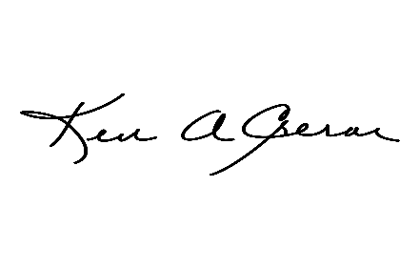
Respectfully submitted,

Ken A. Crerar
President/CEO
The Council of Insurance Agents & Brokers
701 Pennsylvania Avenue NW
Suite 750
Washington, DC 20001
202-783-4400
ken.a.crerar@ciab.com

Federal Housing Finance Agency, Notice of Proposed Rulemaking, Enterprise Regulatory Capital Framework, 85 Fed. Reg. 39274 (June 30, 2020).

