June 6, 2018

Mr. Alfred M. Pollard
General Counsel
Federal Housing Finance Agency
400 Seventh Street S.W.
Washington, D.C. 20219

Re: Notice of Proposed Rulemaking and Request for Comments –
RIN 2590-AA83 – Affordable Housing Program Amendments
Dear Mr. Pollard:
On behalf of our member financial institutions, the vast majority of which are also members of the Federal Home Loan Bank of Boston, we write to register our concerns with the FHFA’s proposed rule on amendments to the Affordable Housing Program.
We are particularly concerned with the proposed changes to project modifications that may be necessary during construction and a proposed move to agency, rather than local and regional focus, on housing priorities. Any efforts to complicate the AHP will serve to lessen participation, especially from our smaller community-bank members which do not have the staffing capacity to meet additional, unnecessary requirements.
Under the proposed rule’s “cure first” requirement, awarded AHP projects that are not able to completely fulfill the commitments made in their AHP applications would be required to attempt to “cure” the issue before requesting a modification to their project. This could increase funding risk and cost, and delay the disbursement of funds. Such delays, in turn, will impact member institutions that have committed construction or permanent financing or are providing equity to the project.
The proposed outcome requirements would direct the majority of the Bank’s AHP contribution to meet FHFA regulatory priorities. This is contrary to the current AHP scoring methodology, which incentivizes projects to meet local and regional housing needs without imposing difficult requirements on them. Because certain outcomes would be required under the FHFA’s proposal, the Federal Home Loan Bank would be compelled to develop its AHP scoring criteria to meet those requirements, which may not align with the local or regional housing needs. This change could certainly hurt communities that have been designated as most in need of housing production, making it more difficult for our members to best serve their constituents.
To date, our member institutions have created 29,890 rental and homeownership housing units through the AHP and have provided grants to 3,177 households through the Equity Builder program across New England. These are significant investments in much-needed housing stock throughout our region and they highlight our member institutions’ commitment to creating and sustaining healthy, vibrant communities.
In summary, we believe that the proposed rule would result in unintended consequences for users and beneficiaries of the AHP, by making the program less flexible, less transparent and generally more complex. The result would be a reduction in the continued ability of member institutions to use the program to best meet local needs.
On behalf of our 250 member financial institutions, we appreciate the opportunity to comment on the proposed rule and thank you for your consideration.
Sincerely,
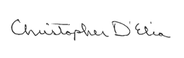 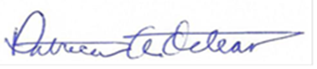Christopher D’Elia, President and Treasurer Patricia A. Octeau, Executive Director
Vermont Bankers Association Rhode Island Bankers Association

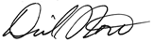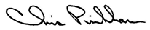
Daniel J. Forte, President and CEO Christopher W. Pinkham, President
Massachusetts Bankers Association Maine Bankers Association
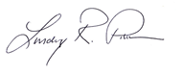 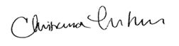Lindsey R. Pinkham, President & CEO Christiana L. Thornton, President & CEO
Connecticut Bankers Association New Hampshire Bankers Association

