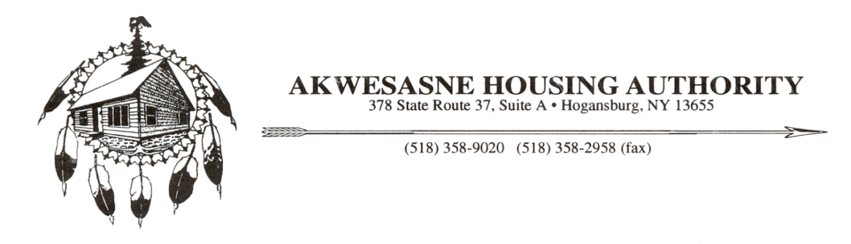

May 7, 2018

Mr. Alfred M. Pollard

Federal Housing Finance Agency

400 Seventh Street, SW

Washington, DC 20219

Attention: Comments/RIN 2590-AA83

Dear Mr. Pollard:

I am the Executive Director for the Akwesasne Housing Authority (“AHA”), the Tribally Designated Housing Entity (“TDHE”) for the Saint Regis Mohawk Tribe (“SRMT”). AHA’s mission is to assist low to moderate income families in providing safe, sanitary housing while offering supportive ventures to families through shared visions and imaginative programming. It has been a struggle to stay inventive with consistently diminishing resources. It was our recognition of the need for diversification of resources that ultimately lead us to the Federal Home Loan Bank of New York.

Subsequently, I became a member of the Federal Home Loan Bank’s (“the Bank”) Affordable Housing Advisory Council (“AHAC”). I was able to obtain the unique position within AHAC, becoming the first Native American member of the committee for the FHLBNY region. I am inspired by the Bank’s actions to provide targeted outreach with a genuine willingness to provide opportunities that have never before been available to tribes.

I can fully appreciate the complexities of the FHFA’s important role in providing effective supervision, regulation, and mission oversight of FHLB systems. However, I have concerns that the pending FHL Bank Affordable Housing Program Notice of Proposed Rulemaking (“AHP Proposed Rule”) reforms would in some ways contradict the very intent of these changes. Even though my work with the region is at the novice level, I believe wholeheartedly in the capacity of the Bank’s institution and foresee that certain changes would place undue strain and complexity on already effective programming.

Needless to say, every system can be improved upon. As such, please be reassured that I am in favor of several positive elements of the proposed rule. These include the retention agreement elimination for homeownership. This would allow discretion by the FHLBs to impose their own rules on retention for certain circumstances. Also, I am in favor of the AHP allocation set-aside that will increase, along with the maximum individual set-aside to $22,000, along with other positive changes. I also appreciate the recent decision of the FHFA to extend the deadline for comments to June 12, 2018, which will allow for more thoughtful and insightful review and responses to the proposed changes.

After my own review of the AHP Proposed Rule, on behalf of the AHA and a concerned member of the AHAC, I would like to provide the following comments on some of the issues I find important.

1. Application Re-Ranking - In 2017, the AHA was fortunate to have been awarded the first Tribal AHP grant in the Bank’s region after one previously failed attempt. If it were not for the Bank’s valuable technical assistance policy, and their personal responsiveness to our project’s goals, I don’t believe we would have been able to overcome the noted deficiencies in our application alone, and eventually secure this much needed funding. As a result, we were approved for a $540,000 award towards the first permanent supportive housing project on a tribal territory in the State of New York. We are testament to the Bank’s policy of personal follow up and their “help not hinder” approach, which I believe was key in our successful application and frankly, a refreshing change from what the Tribe typically meets with from prospective funders.

The proposed “re-ranking” of applications during the decision rounds will eliminate the transparency and competitive nature of the AHP. Even more alarming is the diminishment of technical assistance, which was crucial to our project. If the re-ranking is adopted, the AHA could no longer feel confident in the Bank’s offerings and we certainly couldn’t effectively advocate for the FHLBNY’s outreach strategies to underserved Native American communities, which has been outlined as a priority in the Bank’s 2017 and 2018 Community Lending Plans.

1. Outcome Structure - The AHA’s new supportive housing project is a slight project compared to those located in metropolitan and urban areas. There has been ongoing discussion at AHAC meetings with regard to smaller more specialized projects and the unique circumstances behind the needs of each community. The proposed “outcome structure” seems to serve to complicate and impose unnecessary limitations on the current competitive and objective scoring criteria. The allocation of AHP awards to outcome-based projects will indeed significantly change the landscape of how the Banks are able to use discretion and flexibility in determining awards. This proposed amendment should be reconsidered for its long term effect on the AHP and the prospective benefit communities.
2. Project Sponsor Qualifications - The AHA has recently made strides to diversify its financing capabilities, with achievement of award level commitments. These efforts have required a significant amount of work through the efforts of expert partners in the field of housing development who are familiar with the funding agency requirements. For the FHFA to require evaluation and approval of an agency’s development team seems unnecessary and shows no trust in the responsibility of the agency to impose their own recourse or policies. To a future participant of AHP funds, I view this rule as an imposition and without merit. This can only deter participation of worthy experts in an already onerous housing development field.
3. AHAC Role - As a new member of the AHAC, I have become aware of the importance of communication between the Bank and the AHAC. These entities consist of practitioners of affordable housing in local communities very much like my own. I thought it amazing insight of such an extensive organization to value the views, experiences, constraints and challenges of these “boots on the ground” agencies, recognizing their diversity, providing direction and empowerment, and trusting that these community leaders have identified their own unique housing needs. The AHP Proposed Rule may diminish these roles and compromise the sharing of critical information between the Bank and the sponsoring agencies.

While I believe that some of the proposed amendments may certainly enhance various oversight issues that the FHFA seeks to generate, some of its intended goals may not fully achieve the spirit of “flexibility” and “coordination” it so suggests. Rather the AHP Proposed Rule seems to be espousing in a direction of other, highly regulated institutions with a similar set of rules. Since the FHLB’s mission reflects a public purpose, all FHLBs are privately capitalized and do not receive federal funding. This realization was why I found the FHLB system so energizing. This not only implies that there is a healthy balance of industry and public policy, but is apparently clear to me that the Federal Home Loan Bank system should never attempt to “become” anything like the branches of government with their complex and bureaucratic set of standards that hinder progress and limit responsiveness to local housing needs.

The housing needs of the Saint Regis Mohawk Tribe are significant and the Affordable Housing Program, in partnership with other major funding sources is our new brand of success in the face of declining resources. We have just begun to achieve some new and exciting housing milestones since our first contact with the Bank, and we wish to continue this momentum for years to come.

I sincerely appreciate the opportunity to weigh in on matters of regulatory change, and look forward to future work with the FHLBNY and AHAC.

Sincerely,



Retha M. Leno

Executive Director

CC: The Honorable Charles Schumer

The Honorable Kristin Gillibrand

The Honorable Elise Stefanik

The Honorable Betty Little

Saint Regis Mohawk Tribal Council

AHA Board of Commissioners