January 12, 2015

Mr. Alfred M. Pollard, General Counsel
Attention: Comments/RIN 2590–AA39
Federal Housing Finance Agency
400 Seventh Street SW, Eighth Floor
Washington, D.C. 20024
Re: Notice of Proposed Rulemaking and Request for Comments – Members of Federal Home Loan Banks (RIN 2590–AA39)
Dear Mr. Pollard:

Georgia Advancing Communities Together represents nonprofit housing organizations working throughout the state of Georgia to develop affordable housing, revitalize neighborhoods, educate homebuyers, and increase financial literacy. As such, we are well aware of the pivotal role that the FHLBank Atlanta plays in the financing infrastructure for the affordable housing industry. This proposed rule would alter the relationship between FHLBanks and their member banks and potentially harm affordable housing.

We believe that this rule will make membership in the FHLBank less attractive to banks and credit unions, since continued access to FHLBank funding will be contingent on new ongoing asset tests. This will no doubt result in decreased lending by the FHLBanks which will hurt earnings. As you know, 10 percent of the net earnings of each FHLBank are directed to fund its Affordable Housing Program (AHP). Since 1990, FHLBank Atlanta has provided $648 million to the AHP to help construct or rehabilitate 73,261homeownership and rental units for low or very low-income residents. Should current and prospective membership in an FHLBank be threatened, FHLBank Atlanta’s ability to provide AHP grants to affordable housing partners will be diminished. Fewer funds will thus be available to provide AHP grants to support very low and low-income housing. With less funding from the federal government, such funding through AHP grants has become even more critical for continued production of affordable housing. Enacting this rule will only harm existing partnerships among banks, affordable housing groups and FHLBanks through the AHP program that keeps at-risk families, veterans, senior citizens and people with disabilities from falling through the cracks.
Mr. Alfred M. Pollard
January 12, 2015
Page 2

Although we are not FHLBank stockholders, we hope that you will recognize us committed stakeholders. The neighborhoods we serve require access to credit to build new housing, rehabilitate existing stock and stimulate community investment. An arbitrary asset test for continued FHLBank membership will achieve the opposite effect and hurt communities in the process. As a stakeholder in this process, Georgia ACT strongly urges the FHFA to withdraw RIN 2590-AA39.

Sincerely,
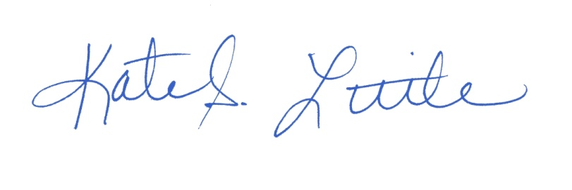
Kate S. Little
President/CEO

