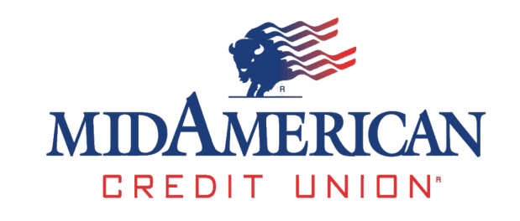
8404 West Kellogg Drive Wichita, Kansas 67209 www.midamerican.org 316-722-3921 Fax 316-722-0920

January 12, 2015

Alfred M. Pollard, General Counsel
Attention: Comments/RIN 2590–AA39
Federal Housing Finance Agency
400 Seventh Street SW
Washington, D.C. 20024

Mr. Pollard:

​ Mid American Credit Union (MACU) is approximately $240 million in assets with around 37,000 members and 8 branches from Arkansas City to Wichita to Larned and Lawrence. We have about 115% of our members funds loaned out most all of the time. This creates a demand for affordable funds. The Federal Home Loan Bank of Topeka has been a great partner of ours for several decades now. In fact, I am told we were the first credit union to join, once membership became available.

Today I want to share my concern about the notice of proposed rulemaking regarding membership in the Federal Home Loan Banks (FHLB) that the Federal Housing Finance Agency (FHFA) recently issued (see the reference in the Attention line above). The proposed rule includes changes to long-standing membership rules for the FHLBank system. The proposed changes are also seem to me to be inconsistent with Congressional intent and the Federal Home Loan Bank Act (FHLBank Act).

The potential for adverse impact the proposed rule could have on MACU seems far ranging and unnecessary. It is difficult for me to understand the need for such a change and I would be interested in engaging further about why the FHFA thinks it is appropriate. It appears the rule could result in fewer members of FHLB Topeka. This could concentrate the risk the FHLB would take in fewer institutions and make the effectiveness of the FHLB less valuable in this region. The potential could make its contributions to the Affordable Housing Program significantly smaller.

Access to FHLBank advances is important MACU. The FHLB Topeka is a valuable partner and a great liquidity source for us. The membership requirements being contemplated by FHFA would change long-standing requirements that have worked well, and the proposed rule would ignore the collateral expansions approved by Congress over time. Because the proposed rule outlines no safety and soundness concerns, because of its potential harm to MACU in serving its 37,000 members and because there seems to be no legitimate public policy goal for it, I request you rescind the proposed rule.

Please contact me if you need additional information.

​Sincerely,
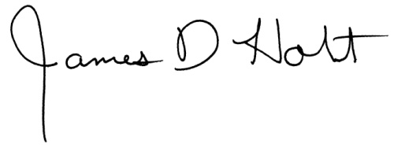
James D. Holt, President

