January 6, 2015

Alfred M. Pollard, Esq., General Counsel

Attention: Comments/RIN 2590-AA39

Federal Housing Finance Agency

400 Seventh Street SW, Eighth Floor

Washington, D.C. 20024

**Re: Notice of Proposed Rulemaking; Request for Comments – Members of the Federal Home Loan Banks**

Dear Mr. Pollard:

​ We are submitting this comment to express our concerns about the Federal Housing Finance Agency’s (“FHFA”) notice of proposed rulemaking and request for comments on “Members of the Federal Home Loan Banks” published on September 12, 2014. For the reasons described below, we respectfully request the withdrawal of this proposal.

**Trustmark Insurance Company** has been providing quality life and health products for over 100 years. Being a member of the Federal Home Loan Bank since 2008 has benefited our policyholders by allowing us to borrow funds at very competitive rates, and by serving as a back-up source of liquidity in times of turmoil in the financial markets.

As a shareholder and customer, we greatly value our membership in the FHLB of Chicago and view it as a key partner in our success. For a company such as ours, access to FHLB liquidity and term funding is critically important because it allows us to offer an array of insurance products that we might not otherwise be able to offer.

The proposed rule would impose, for the first time ever, on-going requirements for our company to meet as a condition of remaining a member of the FHLB of Chicago. For insurance companies, the proposal would require us to hold at least 1 percent of our total assets in long term home mortgage loans (meaning home mortgage loans with a term to maturity of five (5) years or greater), however it also considers increasing the requirement to 2 percent or 5 percent. Failure to meet the requirement would result eventual termination of our membership in the FHLB of Chicago. Additionally, all captive insurance companies would be barred from joining the FHLBs and existing captive members would have their memberships terminated over a five year period.

This proposal is troubling for many reasons. While the proposed requirement may not appear to the FHFA to be onerous, the practical consequences would be very severe and disruptive. To begin with, our ability to rely on the liquidity provided by the FHLB of Chicago, particularly in times of economic distress, would be seriously undermined if the FHFA is allowed to establish requirements we must meet simply to remain a FHLB of Chicago member. This has never been the case in the 82-year history of the FHLBs. Membership in the FHLBs has been steadily expanded by Congress over the years, never contracted. With the imposition of such a requirement, we could never be assured that when the next financial crisis occurs we will have continued access to FHLB of Chicago liquidity.

An estimate of the impact of this proposal shows that the proposal would severely limit the number of insurance companies which would remain eligible for FHLB membership, more than any other category of members. Had this requirement been in effect over the previous six years, from 2008 to 2013, more than 21 percent of insurance company members would have failed an ongoing 1 percent test or would have been otherwise ineligible at least once during this time period. If the requirement were set at 5 percent, the failure rate for insurance company members of an FHLB leaps to 46 percent, or nearly half.

The failure rates among the different categories of insurance companies are very significant as well. Twenty-one percent of property and casualty (P&C) insurance company members would have failed an ongoing 1 percent test while 10 percent of life insurance company members would have failed at that level. If the required level is set higher, such as 5 percent, the number of insurance company members that would have failed rises significantly to 46 percent for life insurance companies and 39 percent of P&C companies. And, of course, 100 percent of captive insurance companies would have been ineligible under the proposal and had their memberships terminated. These requirements would limit dramatically the ability of the insurance industry to take advantage of the many benefits of the FHLBs and strongly discourage prospective members from joining.

By requiring us to hold a certain amount of long term home mortgage loans at all times, the proposal effectively would allow the FHFA to control a portion of our balance sheet as a condition of remaining an FHLB of Chicago member. Our asset allocation potentially could become over-invested in housing related assets at the expense of other asset classes in which we might otherwise wish to invest. This result also would contradict the intent of Congress, which has explicitly recognized the FHLBs’ mission of providing liquidity to members without limiting that purpose to housing finance. By seeking to establish a housing finance nexus that all FHLB members must meet, the proposal does not appear to recognize the legitimate uses of FHLB funding beyond housing finance activities.

Additionally, once the FHFA has established that it can impose requirements for remaining an FHLB member, there would be nothing to prevent it from increasing those thresholds, or imposing entirely new requirements, in the future. As mentioned, the proposal already contemplates increasing the minimum threshold from 1 percent to 2 percent or 5 percent. What would prevent the FHFA from stopping there? This proposal might simply be the first of many such eligibility requirements imposed upon FHLB members, purportedly in an effort to ensure a sufficient housing finance nexus is maintained at all times by members. In essence, this could lead to the politicization of FHLB membership. The FHFA director is a political position, appointed by the President and confirmed by the U.S. Senate. A future FHFA director might be tempted to try and encourage FHLB members to hold yet more housing loans or other types of assets on their balance sheets in order to achieve a certain political agenda. Such fears are not unfounded. Past Administrations from both political parties increased housing goals for Fannie Mae and Freddie Mac in an effort to increase the level of homeownership and serve politically favored constituencies, with disastrous results.

A similar concern exists as to the ability to terminate the memberships of current FHLB members without any showing of cause. The proposal would establish the authority of the FHFA to terminate the current memberships of captive insurance companies regardless of the amount of home mortgage loans they hold on their balance sheets. This would occur despite the fact that captives are insurance companies, which have been eligible to be FHLB members since the FHLBs were created by Congress in 1932. If the FHFA can terminate the memberships of a certain class of insurance companies, it raises a legitimate concern as to what, if anything, would prevent it in the future from terminating the memberships of other types of current members, potentially including insurance companies such as ours, for any reason it sees fit. Such an outcome would destroy any confidence in the FHLBs as sources of stable and reliable liquidity. The FHFA would be opening a Pandora’s Box if it approves the rule as proposed.

Additionally, the proposal’s redefinition of “insurance company” to mean “a company whose primary business is the underwriting of insurance for nonaffiliated persons or entities” for purposes of FHLB membership is problematic. The proposal does not discuss how an FHLB should determine an insurance company’s “primary business”. Additionally, this definition may also eliminate from membership “traditional” insurance companies that also reinsure a significant portion of their affiliate’s business. Mutual insurance companies, which by definition are owned by their policyholders, may be captured by this proposed “insurance company” definition since their policyholders may be viewed as affiliated parties, thus making them ineligible for FHLB membership.

Regardless of the FHFA’s intent to exclude captive insurance companies, the fact remains: captive insurance companies are insurance companies. They are subject to the same regulatory bodies and oversight as are other insurance companies including regulatory requirements for supervision, conservation, rehabilitation, receivership and liquidation. Additionally, similar to other insurers, the ability of a captive insurance company to either lend money or pay dividends to affiliated organizations is tightly regulated and generally requires prior review and written approval from the state insurance commissioner. The FHFA should not be dictating the types of permissible insurance products for insurance company members, or for any members.

The NPR focuses on entities that are not eligible to become members (i.e., real estate investment trusts, “REITs”) using captives to gain access to the FHLB System. However, the parent of an eligible member, whether the parent is a REIT or a holding company, should not affect the eligibility of membership for its subsidiaries. The importance of captives, and REITs, in promoting the FHLB’s housing finance mission has been recently highlighted by the U.S. Treasury Department. Michael Stegman, an advisor to Treasury Secretary Jack Lew has pointed out that while advances made to captive members pose “potential incremental risks to the FHLB System,” the activities of REITs in providing an important source of private capital for the housing market appear to be aligned with the housing finance mission of the FHLBs.

We are also concerned about the proposed redefinition of an insurance company applicant’s principal place of business. While this change would only apply to prospective insurance company applicants, the application of this test could impact current insurance company members. For example, if a current member merged with another member of a different FHLB, or chose to re-domicile its place of business to another FHLB district, application of the proposed principal place of business definition could cause confusion as to which FHLB district is the correct district for membership and require the FHLBs involved to agree on the determination of the appropriate district for the surviving institution. The current regulation’s emphasis on an applicant’s state of domicile as the determinative factor of FHLB membership location works well. Insurance companies are subject to pervasive and ongoing regulation and contact with their domiciliary states, including being subject to comprehensive examinations and ongoing reporting requirements and being required to obtain regulatory approval prior any merger, acquisition or consolidation. The corporate powers of an insurance company such as the authority to borrow and pledge assets to secure borrowings are governed by the state of domicile’s insurance code. That state’s regulator also will oversee the rehabilitation or liquidation of the company, if necessary. This would undermine the importance of domicile and create needless confusion.

Another concern centers on the proposed requirement for an insurance company applicant to submit its most recent audited financial statements. This is unnecessary and unjustified. Some state insurance regulators do not require their regulated companies to submit such documents. Imposing this requirement for such insurance companies would impose a financial burden, requiring the company to weigh the benefits of its FHLB membership against the costs of obtaining audited financial statements. No statistics have been offered demonstrating that insurance companies are being admitted as FHLB members that do not satisfy the financial condition requirement. Before imposing this burden, the FHFA should demonstrate that its concerns are real.

Finally, the overall intent of this proposal seems to restrict and narrow FHLB membership, resulting in fewer members. We are concerned about the destabilizing effects that would result as some members have their memberships terminated while others engage in inefficient activities merely to maintain their membership. These actions will likely lead to smaller FHLBs with fewer assets, reduced profits, lower retained earnings, and a decreased market value of equity and capital stock. As a result, less money will be available to support the FHLB’s economic development programs.

In conclusion, we view the FHLB of Chicago as a critical partner and a key source of liquidity. This proposal would threaten our access and undermine the reliability of the FHLB, discourage prospective members from joining, potentially politicize FHLB membership and constrain the FHLB’s ability to serve its members and our constituencies. Despite these real and damaging effects, there appear to be no specific benefits that would be achieved by this proposal. The costs clearly outweigh the benefits. For these reasons, we strongly urge the immediate withdrawal of this proposal.

We appreciate the consideration of our views.

​ Sincerely,

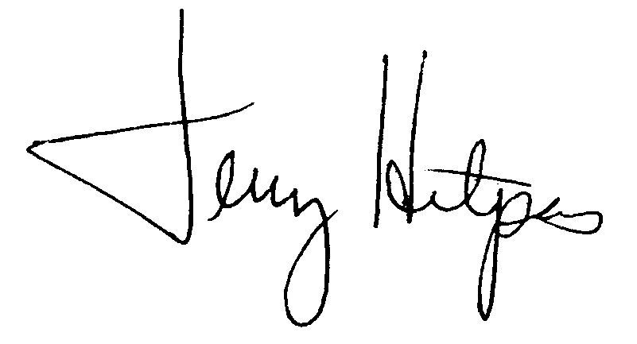

Jerry Hitpas

Sr. Vice President & Chief Investment Officer

cc:

cc: Larry Barry, Illinois Life Insurance Council