Alfred M. Pollard, General Counsel
Attention: Comments/RIN 2590-AA39
Federal Housing Finance Agency
400 Seventh Street SW
Washington, DC 20024

RE: Notice of Proposed Rulemaking (NPR) and Request for comments-Members of the FHLBanks (RIN 2590-AA39).
Dear Mr. Pollard:
I am writing to comment on the Federal Housing Finance Agency’s (FHFA) proposed rulemaking on “Members of the Federal Home Loan Banks”. I have served on the Federal Home Loan Bank of Des Moines (FHLB Des Moines) board of directors as an independent director for seven years. Prior to my retirement I served as the President of the mutual fund business at Ameriprise Financial and have had a 30-year career in the financial services industry with a primary focus on the asset management industry.
Mission of the FHLB System. The FHLBanks mission is clearly stated as both housing and community lending. Congress purposely expanded the mission of the FHLBanks beyond housing 25 years ago with the inclusion of commercial banks and credit unions. Congress changed collateral requirements for Community Financial Institutions (CFI) in recognition of the need for small business, agricultural and commercial lending in support of communities. Congress again expanded membership by adding non-depository Community Development Financial Institutions (CDFI) as eligible members. Congress has recognized that there is a balance between economic development, community stability, housing and the availability of liquidity.
This new test seems unnecessary given that collateral rules already require significant real estate assets to be able to borrow long term. The connection to housing is already established by existing statue. There is no need to further limit the mission of the FHLBanks given that Congress has consistently expanded the mission while leaving this specific nexus to housing in place. This proposed rule directly contradicts the legislative history, particularly in recent decades, that has expanded both membership and mission.
Impact on FHLB Members. The proposed rule would put the FHLBanks in the position of telling our members how to manage their balance sheet. This would seem more appropriate to their primary regulator.
These members may, at any given time, not be in compliance with the ongoing test as they manage their balance sheet to the economy. It adds another compliance issue that may even be contrary to compliance required by their primary regulator.
The FHLBanks have worked diligently to establish a relationship of trust with our members. We have consistently been there for them whether in a crisis or in providing funding for them to best manage their financial institution, providing just-in-time and long-term funding for their lending activities.
These new tests introduce uncertainty that has not previously existed in the FHLBank system. A member may become ineligible at the exact time that they need liquidity to provide loans to their community or meet a financial crisis. Members can move between the 10 percent test and the 1-5 percent test simply by an increase or decrease in assets in relation to the Community Financial Institution designated limit. This puts them in the position of managing their assets to maintain membership when the economy or regulation may dictate other actions.
Our smaller members, especially those in rural areas, will be disproportionally impacted. They do not have access to the global markets and would certainly, in a crisis, have the least access to sources of liquidity. In fact, loss of membership would also eliminate their ability to sell mortgage loans to the FHLBanks. The proposed regulation would perversely harm housing production and homeownership.
The proposed regulation does not provide a compelling rationale for creating on-going membership requirements. The FHFA’s own research purports to show little impact on membership. The reality is that the impact is not in financing more housing but in creating uncertainty of liquidity, potentially eliminating members that sell mortgages rather than hold them, reducing the potential income of the FHLBanks which in turn would reduce the contribution to affordable housing by millions of dollars. We believe some banks would be eliminated from membership, leaving those financial institutions without a source of liquidity in a crisis.
Captive Insurance Company Membership. Insurance companies have been eligible to become FHLBank members since the FHLBanks were created in 1932. While the FHLB Act does not define “insurance company,” the FHFA is proposing to exclude captive insurance companies from membership eligibility.
Captive insurance companies are formed to underwrite risks of both affiliated and nonaffiliated entities. Captive insurance companies are subject to the same regulatory bodies and oversight as other insurance companies including regulatory requirements for supervision, conservation, rehabilitation, receivership and liquidation. Additionally, similar to other insurers, the ability of a captive insurance company to either lend money or pay dividends to affiliated organizations is regulated and generally requires prior review and written approval from the state insurance commissioner. The FHFA should not be dictating the types of permissible insurance products for insurance company members, or for any members.
As a participant in the asset management industry for thirty years, I believe I am qualified to understand how an organization like Two Harbors Capital Management (a recent captive insurance company member) operates. The board of directors of FHLB Des Moines met directly with senior leaders of Two Harbors Capital Management and debated their application over several months. FHLB Des Moines has developed systems and expertise over a 20-year period in the analysis of these entities both for inclusion in membership and for ongoing credit analysis. We have not had a credit issue with any insurance company members (including during the recent financial crisis). We have met with insurance regulators in both Iowa and Missouri to proactively discuss steps we would take in the event of a failure. Insurance company membership is clearly an area of deep expertise for the Des Moines bank. We are satisfied that we have the infrastructure to manage relationships with the captive insurers who are our members.
I can understand the discomfort the agency feels with the changing mortgage finance industry. It is clear that the marketplace is doing what it does so elegantly – when there is a vacuum the market moves to fill it. As FNMA has diminished in its capacity to fund mortgages, the market is stepping in to fill the breach. Until policy makers decide there is a better approach, I believe that with appropriate collateral and credit assessment it is appropriate for the FHLB system to provide a source of funding to these captive insurance companies who fund residential mortgages.
We would respectfully ask you not to eliminate captive insurance companies but rather work with us to make any appropriate design modifications to the current framework.
Sincerely,
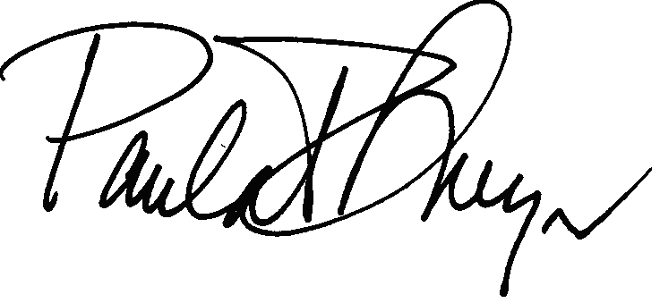
Paula R. Meyer
Independent Director, FHLB Des Moines

