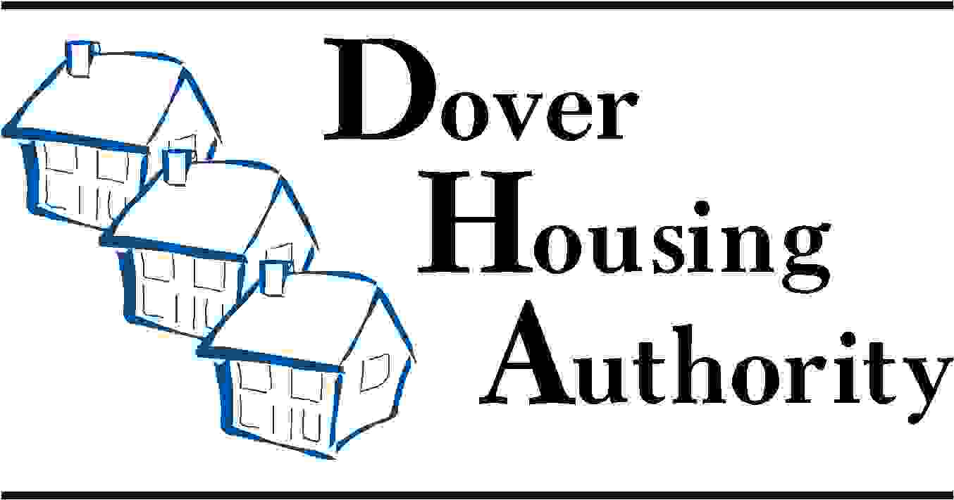

76 Stevenson Drive
Dover, DE 19901
302-678-1965 voice
302-678-1971 fax
1-800-545-1833, ext. 816 TDD
dover.housingauthority@dhade.org email

Alfred M. Pollard, General Counsel
Attention: Comments/RIN 2590–AA39
Federal Housing Finance Agency
400 Seventh Street SW, Eighth Floor
Washington, D.C. 20024

Re: Notice of Proposed Rulemaking and Request for Comments – Members of Federal Home Loan Banks (RIN 2590–AA39)

Mr. Pollard:

Dover Housing Authority is an affordable housing partner that works closely with community lenders and FHLBank Pittsburgh. We know the crucial role FHLBanks serve in providing funding for community banks. This proposed rule would alter the relationship between FHLBanks and their member banks and potentially harm affordable housing.

Dover Housing Authority has partnered with FHLBank Pittsburg on the construction of new elderly housing and to expand the home ownership opportunities in the downtown Dover, DE area.

This rule will make membership in the FHLBank less attractive to banks and credit unions since continued access to FHLBank funding will be contingent on new ongoing asset tests. This will no doubt result in decreased lending by the FHLBanks which will hurt earnings. Ten percent of the net earnings of each FHLBank are directed to fund its Affordable Housing Program (AHP). Since 1990, FHLBank Pittsburgh has provided approximately $183 million in AHP grant awards to create more than 28,000 units of housing for low or very low-income residents. Should current and prospective membership in an FHLBank be threatened, FHLBank Pittsburgh’s ability to provide AHP grants to affordable housing partners will be diminished. Fewer funds will thus be available to provide AHP grants to support very-low and low-income housing. There exists a stable partnership between banks, affordable housing groups and FHLBanks through the AHP program that keeps at-risk families, veterans, senior citizens and people with disabilities from falling through the cracks.

We may not be FHLBank stockholders, but we are stakeholders. The neighborhoods we serve require access to credit to build new housing, rehab existing stock and stimulate community investment. An arbitrary asset test for continued FHLBank membership will achieve the opposite effect and hurt communities in the process. As a stakeholder in this process, Dover Housing Authority strongly urges the FHFA to withdraw RIN 2590-AA39.

Sincerely,

Ami Sebastian-Hauer
Dover Housing Authority
76 Stevenson Drive
Dover, DE 19901

