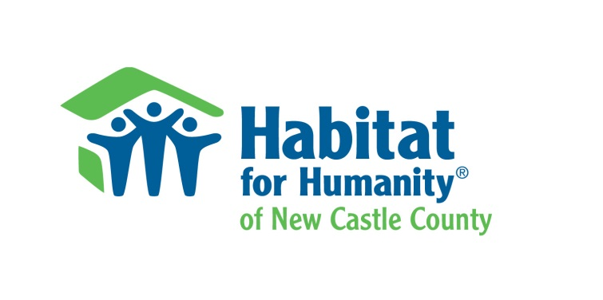
1920 Hutton Street  Wilmington, DE 19802  www.habitatncc.org |  | phone 302 652 0365  fax 302 652 1006  Tax ID 51-0294138

Alfred M. Pollard, General Counsel
Attention: Comments/RIN 2590–AA39
Federal Housing Finance Agency
400 Seventh Street SW, Eighth Floor
Washington, D.C. 20024
BOARD OF DIRECTORS

Noreen Poole
Board President
Rick J. Gessner, Jr.
Vice President
Hal Schneikert
Vice President
Celia Huber
Treasurer
Kim Walker
Secretary

George Beer
Weston Dinsel
Augusta Gladd
Bob Hopkins
Ted Kelly III
Annabelle C. Kressman
Vanessa Phillips
Chip Rankin
Dave Wolfenden
CHIEF EXECUTIVE OFFICER

Kevin L. Smith

Re: Notice of Proposed Rulemaking and Request for Comments – Members of Federal Home Loan Banks (RIN 2590–AA39)
Mr. Pollard:

Habitat for Humanity of New Castle County (HFHNCC) is an affordable housing partner that works closely with community lenders and FHLBank Pittsburgh. We know the crucial role FHLBanks serve in providing funding for community banks. This proposed rule would alter the relationship between FHLBanks and their member banks and potentially harm affordable housing.

For many years, HFHNCC has been the beneificary of FHLBank AHP funds, helping to create and sustain homeownership for over 50 families.

This rule will make membership in the FHLBank less attractive to banks and credit unions since continued access to FHLBank funding will be contingent on new ongoing asset tests. This will no doubt result in decreased lending by the FHLBanks which will hurt earnings. Ten percent of the net earnings of each FHLBank are directed to fund its Affordable Housing Program (AHP). Since 1990, FHLBank Pittsburgh has provided approximately $183 million in AHP grant awards to create more than 28,000 units of housing for low or very low-income residents. Should current and prospective membership in an FHLBank be threatened, FHLBank Pittsburgh’s ability to provide AHP grants to affordable housing partners will be diminished. Fewer funds will thus be available to provide AHP grants to support very-low and low-income housing. There exists a stable partnership between banks, affordable housing groups and FHLBanks through the AHP program that keeps at-risk families, veterans, senior citizens and people with disabilities from falling through the cracks.

The neighborhoods we serve require access to credit to build new housing, rehab existing stock and stimulate community investment. An arbitrary asset test for continued FHLBank membership will achieve the opposite effect and hurt communities in the process. As a stakeholder in this process, HFHNCC strongly urges the FHFA to withdraw RIN 2590-AA39.

Sincerely,

Kevin L. Smith
Chief Executive Officer

