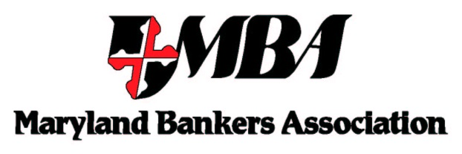

September 5, 2014

The Honorable Melvin L. Watt
Director
Federal Housing Finance Agency
400 7th Street, SW
Washington, DC 20024

Regulatory Information Number (RIN) 2590–AA39

Re: Proposed Rule — to revise the requirements for financial institutions to apply for and retain membership in one of the 12 Federal Home Loan Banks (Banks)

Dear Director Watt:
On behalf of our members, the Maryland Bankers Association (MBA) respectfully submits this letter requesting additional time to comment on the FHFA’s proposed rule RIN 2590-AA39. The proposed rule would revise FHFA’s existing Bank membership regulation to ensure that members maintain a commitment to housing finance and that only eligible entities can gain access to Bank advances and the benefits of membership. The proposed rule was issued on September 2, 2014 with a 60-day comment period. The proposed rule will have a significant impact on MBA member banks – almost all of which are FHLBanks members - and the Maryland banking industry and we request additional time to assess the impact of this complex rule change. MBA respectfully recommends the comment deadline be extended to provide a more adequate timeframe to assess and comment on this important rule change.

Founded in 1896, MBA is the only Maryland-based trade group representing banks in the state. The 121 banks operating in Maryland hold in excess of $120 billion in FDIC-insured deposits in about 1,800 branches across the state. The banking industry employs more than 45,000 banking professionals in Maryland. MBA’s members include banks of all sizes and charter types including: Maryland state-chartered banks, national banks and thrifts, and state banks chartered outside of Maryland.

Thank you for your consideration of MBA’s concerns and recommendations. Please contact me if you have questions or would like to discuss MBA’s concerns in greater detail. Thank you for your consideration of MBA’s position and for the opportunity to comment on this critical proposal.

Sincerely,

Kathleen M. Murphy
President and CEO
Maryland Bankers Association

