

J. Russell Boyce
2014 President

March 12, 2014

Federal Housing Finance Agency (OPAR)
Constitution Center
400 7th Street SW, 9th Floor
Washington, DC 20024
loanlimitinput@fhfa.gov

RE: [No. 2013-N-18]

To Whom It May Concern:

On behalf of the 22,000 members of the Maryland Association of REALTORS®, I am writing to comment on the above referenced notice, “Fannie Mae and Freddie Mac Loan Purchase Limits: Request for Public Input on Implementation Issues.”

We urge you to NOT change the existing loan limits, which have been critical in restoring stability to local housing markets across Maryland.

Though there has been nominal improvement in the housing market, purchasing a home remains a challenge for many potential homeowners, in large part due to the restrictive availability of credit, particularly if available loans cannot be purchased or insured by the government sponsored entities (GSEs) or FHA. Borrowers in areas affected by the contemplated reduction in loan limits rely on the liquidity that the GSEs provide. They will have difficulty qualifying under the tight credit standards currently required by private lenders, including the 20% down payment requirement that is a minimum for most of these lenders.

Outside of the GSEs and FHA, credit remains limited and available only to the wealthiest borrowers with pristine credit. These conditions leave the American dream of home ownership out of reach for many families, and slow the recovery of the housing market, which in most states, including Maryland, is a significant contributor to the state’s economic health.

In the Federal Register announcement on December 23rd, FHFA noted that reducing the loan purchase limits is consistent with its legal authorities as conservator provided under the Housing and Economic Recovery Act of 2008 (HERA). We do not agree. Rather, we believe that by making a decision to lower the purchase limit, FHFA would be superseding congressional intent under that same law which:

- Established the maximum loan limit for loans purchased by the GSEs; and
- Made it a principal duty of the Director to ensure that the GSEs serve as a reliable source of liquidity and funding for housing finance and community investment.
Maintaining a steady, nationwide floor for the GSE loan limits contributes to stabilizing housing prices, the stability of the housing finance system, and consumer confidence. Continued downward pressure on the limits adds to the uncertainty in mortgage markets and discourages buyers as well as sellers.

It’s crucial that the federal government act to maintain market stability, not add disruptive and unnecessary changes at this critical time in the nation’s economic recovery. While the housing market continues to experience a nascent recovery, data reflects that it remains fragile. Based on market conditions and the terms of the Housing and Economic Recovery Act of 2008, we urge you to not take steps, such as reducing limits that will only restrict consumer access to mortgage credit.

Sincerely,

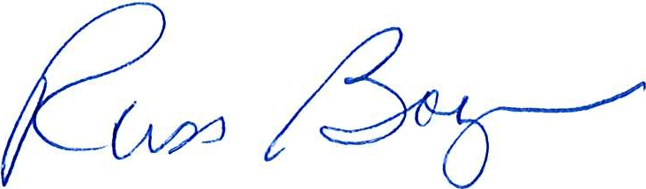

J. Russell Boyce
President

