March 30, 2018

The Honorable Mel Watt

Director

Federal Housing Finance Agency
c/o Office of Housing and Regulatory Policy
400 7th Street, S.W.
9th Floor

Washington, D.C., 20219

Dear Director Watt

On behalf of the National Consumers League, we appreciate the opportunity to provide some comments and questions for your consideration as part of your December 17, 2017 Request for Input (RFI) on “operational and competition considerations of changing Fannie Mae and Freddie Mac’s (the Enterprises) current credit score requirements.” We greatly appreciate your transparent and open process.

Our primary goal in writing is to consider the situation of the broad array of consumers who hope to have the opportunity to own their own home. NCL isn’t an expert in credit scores, and we can’t fully respond to each and every part of the RFI, but we do want homebuyers to be able to navigate the market and get the information they need to make good choices. In this vein, we have a few questions and concerns as you move toward final decisions.

Here are our questions and concerns:

#1 - Will the changes in the scoring process proposed in the RFI lead to more Americans getting scored, will they get scores that actually help them be considered as qualified to buy homes and will these proposed changes actually help the “credit invisible”? We have reviewed some of the submissions to your RFI that argue that both FICO and Vantagescore use the same data to create their scores. Will adding another score to the mix, as one of your proposals in the RFI lays out, will ensure more people get scored? Not all credit scores are equal. Would this process possibly result in more consumers receiving subprime scores and getting locked out of the market? Is no score better than a subprime score for consumers? The GSEs currently have a manual underwriting program that is quite successful that helps those who do not have a credit score.

#2 - We agree there’s a need for alternative data used in determining credit scores, but we aren’t sure that the proposals you are currently considering will actually achieve that. There has been a great deal of misinformation out there about what FICO and Vantagescore include and don’t include in their scores. As we mentioned above, both scores currently draw from the same set of data from the credit bureaus.

We believe that more must done by FHFA going forward to find new sets of data to supplement what is found from the credit bureaus to help score more consumers based on fair and accurate information – which can, in turn, them a chance at getting a mortgage they can afford. This includes looking at things like utility payments and telecom data in their XD score. Some experts have raised the idea of using mobile payment history. The US Treasury Department and other agencies have conducted pilot programs exploring potential new sources of good data.

#3 - We believe in competition, but it is important that we look at competition from all sides. It is our understanding that FHFA reviews scores periodically and can change who they pick at any time. You are not locked into one score or another, one company or another. Will adopting parts of this proposal give too much power to the credit bureaus or to one company? We have some questions about how the process would work if the organizations who control a vast majority of consumer data at credit bureaus are also allowed to sell scores. What does that mean for prices and for competition in the marketplace?

#4 - What is the impact on consumers if you do adopt a two score systems? Could this delay – or will it improve - the process of getting a mortgage and a home, especially for homeowners who are purchasing mortgages through the GSEs? What kinds of costs would result in this change for FHFA, for the GSEs, the mortgage companies, for banks and most importantly for taxpayers and consumers? We also see, at times, hidden and not so hidden costs passed on to consumers.

In conclusion, we hope that you and your staff will consider these questions and concerns as you review the information and data that has been submitted and that your open process will be allowed to proceed. We are troubled by recent news reports that an amendment added to the Financial Choice Act that just passed the US Senate could delay the RFI process that you have already undertaken. We believe consumers need answers, and we want your agency to have the ability to complete your process without political interference. That will be best for the consumers who are our primary concern in this RFI.

Thank you,

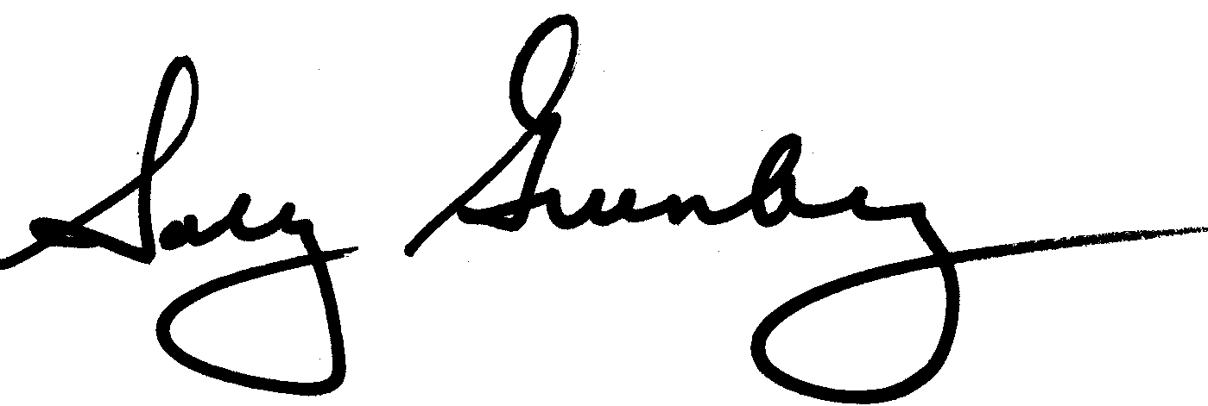

Sally Greenberg
Executive Director
National Consumers League

