July 26, 2023

Federal Housing Finance Agency
400 7th Street, SW
Washington, D.C. 20219

Re: Request for Input on Multifamily Tenant Protections

Dear Director Thompson,

Thank you to the Federal Housing Finance Agency (FHFA) for issuing a Request for Information (RFI) on tenant protections in properties with federally-backed mortgages. My name is Edward Goetz, and I serve as the Director of the Center for Urban and Regional Affairs at the University of Minnesota, and a professor of urban planning at the Humphrey School of Public Affairs. My research focuses on issues of race and poverty and how they affect housing policy planning and development; topics that frequently intersect with issues of tenant protections. In addition to signing on to a letter supporting various tenant protections with more than 100 of my colleagues at universities across the country, I submit this individual comment to provide additional support and information on rent regulations, specifically. Rent regulations play an important role in our housing policy landscape to advance racial equity in the rental housing market and have been proven to work at increasing housing stability and affordability for current tenants.

My comment speaks to Questions A-7 and E-1 of the RFI:
- A-7: With respect to the foregoing questions, FHFA invites interested parties to submit any studies, research, legal analysis, reports, data, or other qualitative or quantitative information that supports a commenter’s response or is otherwise relevant.
- E-1: What are the potential short-term and long-term financial benefits and risks associated with requiring certain tenant protections at Enterprise-backed multifamily properties, and how might such benefits and risks change over time?

In 2021, the Center of Urban and Regional Affair was contracted by the City of Minneapolis to study rent stabilization policies to inform policy development in Minneapolis. This analysis included a study of the city’s rental market in the preceding 20 years and an economic analysis that included financial scenario modeling of how various annual rent caps impact return on investment in the Minneapolis market. The results of this study can be found here.

It is important for the FHFA to consider this analysis from the Center of Urban and Regional Affairs because it is one of the few examples of financial modeling of rent stabilization scenarios that exist across the country. Arguments made against rent stabilization policies often rely on theory or economic models; very few rely on actual financial modeling. In considering the “risks” of implementing rent stabilization, especially those related to housing supply, this research demonstrates that there is a relatively low level of risk to future housing development directly related to rent stabilization policies because – according to the scenarios – they don’t impact various measures of return or pre-existing rental increase practices in the Minneapolis market. Of course, housing supply is more heavily influenced by economic factors and conditions, such as interest rates, the global supply chain, nationwide labor shortages, and more – some of which happen to change at the same time rent regulations are introduced in jurisdictions. But the financial modeling demonstrated in the Minneapolis report shows that when looking only at the impact of rent stabilization on measures of return, there is very little impact - and the assumption can be made that when profit and returns aren’t impacted, there are few reasons to stop developing. A detailed summary of the financial scenario modeling can be found below:

Scenario Modeling
The purpose of this part of the study was to explore how different rent caps would affect the economics of apartment properties. We modeled these outcomes for the 10 most recent years for which rent data were available. We chose a 10-year ownership period because that is the typical investment horizon used by investors.

Methodology:
The models were based on the following:
- The pro forma model is of a single typical market rate, class C or NOAH type apartment unit. It can be scaled to any number of units (a fourplex, 20 units, 50, 100, etc.).
- Informants suggested that rents for class C apartment units in 2019 were between $900 and $1,050, for an average of $975.
- Median rent for a Minneapolis apartment in 2019 was $984, which is close to the average of $975, so we used Minneapolis median rents as a proxy for class C rents. (The average apartment rent in 2019 was higher, $1,097, a figure driven up by outliers at the top of the market.)
- We then used median rents in starting years (2004/2009) and tracked annual rent increases at the average, median, and 90th percentile, and compared those returns against what would have been possible under four hypothetical rent caps (75% of CPI, CPI, CPI + 3%, and CPI + 7%).
- We included assumptions for vacancy, miscellaneous income, and expense rate of growth, capital reserve, and debt service.

We measured the economic performance of our modeled building using five different metrics that investors use to assess the attractiveness of investment options:

1. Cash-on-cash return (average annual returns)
2. Cash-on-cash return in the final year (2018)
3. Average annual change in value (appreciation)
4. Total change in value (appreciation)
5. Internal rate of return (IRR)

Our model provides measures of return to owners/investors in percentages that can be compared across different scales of properties. This model can be scaled to any number of units. The returns as percentages would not change.

The five tables below show measures of return for example rent caps of 75% of CPI, CPI, CPI + 3%, and CPI +7%, as well as how these measures of return compare to the Minneapolis average, median and high.

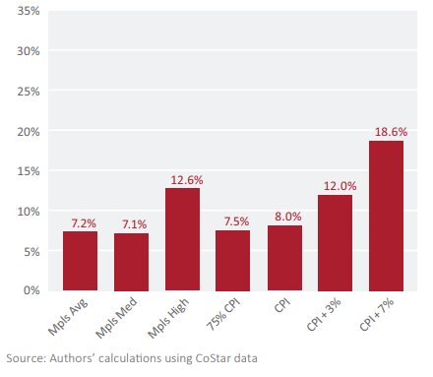
Figure 1: Cash-on-Cash Return: Average Return 2009-2018

The figure shows that landlords who increased rents at the average and the median of all units in Minneapolis over this 10-year period would have achieved industry-expected minimum returns (7.2% and 7.1%, respectively). More aggressive landlords who raised rents at the 90th percentile would have realized an average return of 12.6% during this time period. Had rent increases been capped at 75% of the CPI or at the CPI, landlords would have been able to achieve acceptable returns (7.5% and 8.0%, respectively). In fact, those returns would have been higher than what would have been achieved by the average and median rent increases over this period. A cap of CPI + 3% would have allowed average annual returns that essentially match what would have been achieved by the most aggressive landlords in the Minneapolis market. In sum, Figure 1 shows that average annual returns at the middle of the Minneapolis market would not have been constrained by any of the caps we modeled.

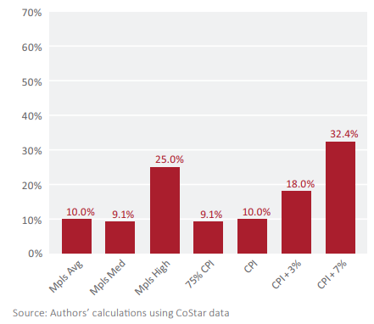
Figure 2: Cash-on-Cash Return in Final Year: 2018

The pattern in Figure 2 echoes that seen in Figure 1. The 2018 return under a 75% CPI and a CPI cap match what would have been achieved through the average and median rent hikes over the 10-year period. The 2018 return under a CPI + 3% cap is less than what the most aggressive owners would have achieved over that period (18% compared to 25%). A cap of CPI + 7% would have allowed a 2018 return well in excess of what the high end of the Minneapolis market would have produced during these years.

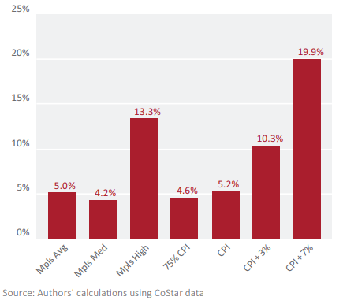
Figure 3: Average Annual Increase in Value, 2009-2018

Figure 3 illustrates the modeled impact of different rent caps on the average annual increase in value. The model indicates that annual rent increases at the CPI would have produced appreciation that matched or slightly exceeded both the average and the median in Minneapolis over this time period. The most restrictive cap we examined, one set at 75% of the CPI, would have constrained the average annual increase in value but would have allowed for greater increase in value than what would have occurred at the median of the Minneapolis market. Higher rent caps would have allowed for greater appreciation than the market average and median.

Figure 4: Total Increase in Value, 2009-2018
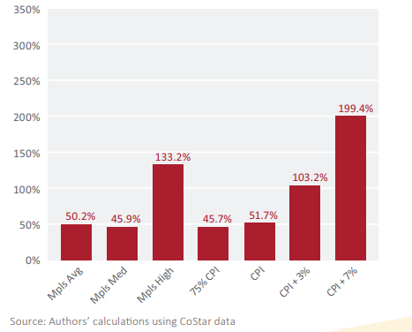
Figure 4 illustrates the total increase in value from the time of purchase through the time of sale. These percentages reflect an increase over 10 years. Indeed, the total increase in value shown is simply 10 times what was shown in Figure 3, and therefore the relative patterns are the same. The two most restrictive caps would have allowed for total increases in value that matched the middle of the Minneapolis market, while the more lenient caps would have allowed for appreciation well above those levels.

Figure 5: Internal Rate of Return, 2008-2019
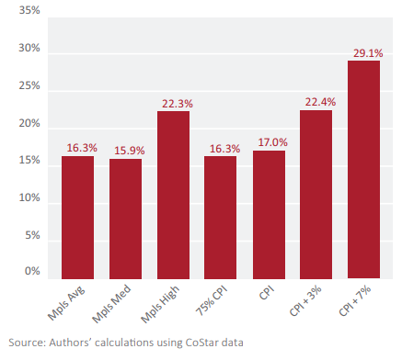
Figure 5 shows that the industry-expected threshold for IRR of 15% is achieved under all of the rent cap scenarios. The 75% CPI and the CPI caps would allow an IRR that matches or slightly exceeds what would have been achieved at the average and the median of the Minneapolis market from 2009 to 2018. A cap of CPI + 3% would have allowed an IRR that matches what the most aggressive owners would have achieved over this period. The most lenient cap (CPI + 7%) would have allowed an IRR far in excess of what would have been achieved at the top of the market.

The results of this study show, through financial modeling, that in the Minneapolis market if all other conditions remained the same, various rent caps would have had a negligible impact on returns for investors and property owners over the 10-year period of our study. At minimum, FHFA should consider this in its risk assessment of how tenant protections impact the market. If it feels so compelled, FHFA should consider replicating this scenario modeling across various housing markets to assess fears of any proposed rent stabilization policies’ impact on profit, and in turn development and long-term housing supply.

Please contact me at egoetz@umn.edu if you would like to speak with me in more detail about this comment.

Sincerely,

Edward G. Goetz
Director, Center for Urban and Regional Affairs
Professor, Humphrey School of Public Affairs

