August 24, 2016

The Honorable Melvin L. Watt
Director
Federal Housing Finance Agency
400 7th Street, SW
Washington, DC 20024

Dear Director Watt:

We appreciate this opportunity to provide comment concerning the Federal Housing Finance Agency’s (FHFA) request for information (RFI) to “assist FHFA and the Enterprises in their ongoing analysis of front-end credit risk transfer transactions in which a portion of the credit risk is transferred prior to Enterprise acquisition of the underlying mortgage”.

We laud FHFA and the Enterprises in their efforts to assess what options are available in the market to help shift risk away from taxpayers, and to “expand the array of credit risk transfer products” available. As a business-to-business lender offering a first response lifeline to troubled borrowers, Job Loss Protection of America (JLPA) is committed to this very goal.

We are concerned, however, that FHFA’s conceptualization of “front end risk mitigation” remains too heavily focused on the point at which “the risk transfer occurs prior to, or simultaneous with, the acquisition of residential mortgage loans by an Enterprise”. In our opinion, a better definition of “front end” protections would focus more heavily on steps lenders and guarantors could take to ensure the actual health and value of the underlying asset. A true front end protection would focus on the borrower themselves, incorporating measures which would protect the borrower, and the health of the financed asset, at the “entry point” – or the actual payment of the monthly mortgage obligation by the borrower.

JLPA coverage (detailed further below) is a true “front end” protection, in that JLPA covers the actual mortgage payment for borrowers who become involuntarily unemployed – unemployment being the single-most prevalent reason for missed mortgage payments. Nearly 70% of all defaults started with a borrower job loss.

For an extremely modest price, JLPA coverage provides borrowers who lose their job up to six months of a “grace period,” wherein JLPA pays the monthly mortgage for up to six months while the borrower gets on their feet.

In doing so, JLPA saves borrowers, families, and lenders from having to wade into the difficulties of triggering traditional mortgage insurance coverage. Rather than being focused on the “Enterprises[‘] ultimate [need to] guarantee the timely payment of principal and interest to investors on all loans included in Enterprise mortgage-backed securities,” JLPA believes it makes better fiscal and public policy sense to protect the borrowers on the front line. As we discuss further below, the advantages of this approach are significant to both borrowers, investors, and the ultimate guarantors.

We are experiencing the slowest recovery from a recession in three generations. Overall growth has been just barely above 1% per year. The U.S. housing market continues to be a major factor driving economic health. Yet there is an inertia that seems to repeat the same old tired cycles.

We must seriously look to the private sector for solutions. The private sector lacks the luxury of trial and error. We simply must get it right or fail.

It is refreshing to know the FHFA seeks suggestions to shelter taxpayers from the risk of another 2008. The ability to distribute risk in the private sector is well demonstrated in the use of private mortgage insurance. There are other vehicles to share risk before a mortgage reaches the GSEs.

In 2001, Job Loss Protection of America, Inc. (“JLP”) structured a unique and niche credit enhancement, “mortgage payment protection”, to make monthly mortgage payments (PITI) to Servicers/Investors in the event the Mortgagor/Borrower became involuntary unemployed. JLP is included “up-front” at loan origination by the lender, private mortgage insurance companies, housing finance authorities, down-payment assistance programs, etc. prior to the acquisition of mortgages of the GSEs.

During the recent financial crisis nearly 70% of all defaults started with a job loss. Loans with mortgage payment protection allowed Borrowers time organize their monthly debt with creditors while the largest monthly obligation was being paid. Not only did borrower stay in their home, Servicers did not have to advance payments, keeping their capital reserves intact. Job Loss Protection stepped in at the most critical time to hedge loan workouts and defaults.

Job Loss Protection a “first responder”. When a mortgage payment is missed, servicer costs to bring the loan current and the advances begin –-- both are costly in time and resources. If payments continue to be missed, other costs begin to mount as the loan heads toward foreclosure. JLP can have a payment on its way usually within 30-45 days from notice of job loss.

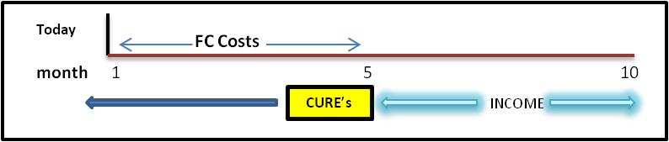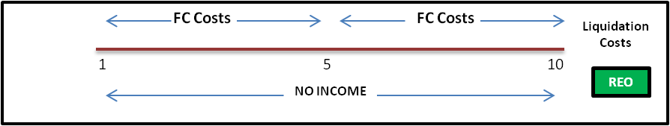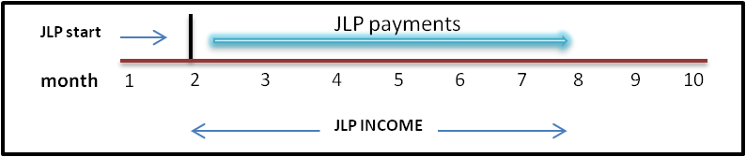
Cost to Cure: $7,500 - $25,000
Default Cost: $25,000 - $60,00+

In June, 2015 the FHFA released its “2014 Report to Congress”. The report outlined the FHFA future strategies:

- MAINTAIN, in a safe and sound manner, foreclosure prevention activities and credit availability for new and refinanced mortgages to foster liquid, efficient, competitive, and resilient national housing finance markets;
[Since a job loss is the greatest threat to the security of a loan portfolio, it’s worthwhile to look at the value proposition of supporting loan originators to include the job loss protection on each loan when it is originated. At a cost of less than $300 per loan to protect the loan against default for the first 24 months (2 yrs) of the loan, servicers save the cost of advances and curing, currently at a reported cost of $7,000 - $15,000]

- REDUCE taxpayer risk through increasing the role of private capital in the mortgage market; and
[Job Loss Protection is poised to reduce taxpayer risk. Since each foreclosure cost an average in excess of $30,000 to $60,000, a loan, with job loss protection is 70% less likely to default when a job loss occurs. Populated coverage on loan portfolios drastically reduces the odds of defaults, HAMP & HARP re-defaults, market disruptions, etc.]

3. BUILD a new single-family securitization infrastructure for use by the Enterprises and adaptable for use by other participants in the secondary market in the future.
[Job Loss Protection strengthens MBS and improves secondary market liquidity to strengthen economic growth.]

Job loss protection assists in fulfilling these strategies as the FHFA by helping to prevent further credit losses. As the FHFA continues to explore alternative ways to lower risk, Job Loss Protection should not be left out as a viable and integral part of overall risk sharing whether upfront or part of other risk sharing deals.

As a lender credit enhancement, the cost heretofore has been paid by the lender, private mortgage insurer, etc. However, consideration should be given to a reduction in guarantee fees to those lenders delivering larger volumes to the GSEs. A portion of the G-fees (roughly 10 bpts) are currently allocated for” unemployment” of the borrower. Including job loss protection would assure a rapid response to preventing defaults and the enforcement and curing costs associated with missed payments.

Program Highlights:

- Provides up to 6 monthly payments (PITI)
- Up to $2,500/month benefit
- Multi-year coverage
- Eligibility: All mortgages
- Joint Mortgagor clause automatically covers co-borrower
- Benefits paid directly to mortgagee/servicer
- Automatic issue to eligible borrowers, simple enrollment
- Portable coverage
- Available in all States

Highlights and Advantages to Job Loss Protection:

Mitigate losses by providing timely and consistent monthly mortgage (PITI) payments to Servicers!
- In the public/taxpayer interest
- Protects Borrower Credit scores, allows continuation of access to credit
- Expands homeownership opportunities by helping homeowners stay in their homes

- Lower dependence of unemployed Borrowers on other government social services such as State/Federal Unemployment benefits, Food assistance, Local/Federal medical assistance
In addition,
•Provides ongoing assistance in the secondary market
•Responds appropriately to capital markets
•Lower re-defaults
•Lower delinquency costs
•Servicer reserves not needed for investor payments
•Increase Servicer performance - helps maintain capital reserves
•Higher performance level of loan portfolios.
•Positive Market impact

Based on the foregoing, we believe true “front end” protections involve measures which keep borrowers in their homes, save their credit and keep them in the credit pool, reduce both the initial and long-term costs associated missed payments and potential default, and better protect the financial health of the actual lenders and guarantors.

Again, we are extremely pleased FHFA and the GSEs are looking for ways to mitigate risk. JLP coverage is an inexpensive and effective way to not only protect the government fisc, but more importantly, for keeping Americans in their homes in times of trouble. To us, that is effective public policy, achieving all the desired outcomes.

Thank you very much for your time and consideration of our comments. We welcome the opportunity to answer questions, and hope to engage in a meaningful dialogue.

Sincerely,
Teri Cooper
EVP Business Development & Market Strategies
Job Loss Protection of America, Inc.
407.444.9990 x226

