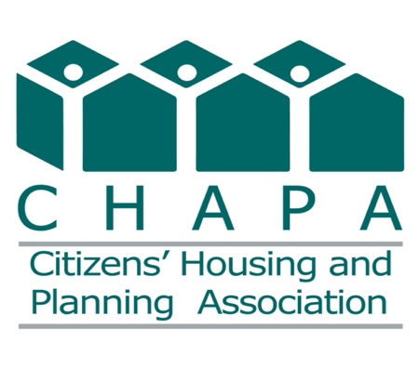

March 31, 2023

Ms. Sandra Thompson
Director
Federal Housing Finance Agency
400 7th Street, SW
Washington, DC, 20024

Dear Director Thompson:

I write in response to the Federal Housing Finance Agency’s announcement of a comprehensive review of the Federal Home Loan Banks (the FHLBanks).

Citizens’ Housing and Planning Association (CHAPA) is a statewide affordable housing and community development advocacy organization with a membership of over 1700 individuals and organizations. As a convenor of diverse stakeholders in MA and New England, CHAPA advocates for resources and policies to promote the production and preservation of rental and home ownership development opportunities for all people in diverse, equitable and sustainable communities of their choice.

My comments below are focused the Affordable Housing Development Competition, which was founded by the FHLBank Boston in 2000. The Competition encourages students who are interested in affordable housing to think carefully about the interconnections between housing, health care, and economic opportunity. By matching graduate students with experienced professionals, the competition provides the opportunity to combine classroom experience with real-world practice in affordable housing development.

CHAPA is an enthusiastic sponsor and supporter of the competition and is proud to have been involved with the competition since its inception in 2000. CHAPA works closely with the Bank to enlist developer partners to bring challenging sites to the competition each year. Our developer partners serve as mentors to the students and expose them to a “hands on” development process over the course of one semester, with emphasis not only on design and finance, but also community engagement, holistic design and sustainability. To date, the competition has included over 1100 students, 57 developers, and 128 sites while fostering a knowledgeable and committed next generation of affordable housing professionals.

For 90 years and counting, the FHLBanks have fulfilled their mission to provide reliable wholesale funding and liquidity and deliver products and services to their members to help communities thrive. In addition, FHLBanks have developed innovative programs such as the Affordable Housing Development Competition to help focus a new generation of thinkers on affordable housing. I am proud of my involvement in this program and commend FHLBank Boston for supporting and enhancing the program going forward. As a result of the Competition, I look forward to welcoming a new generation of affordable housing professionals to our community.

Thank you for the opportunity to provide a comment on the review.

Sincerely,

Rachel Heller
Chief Executive Officer

