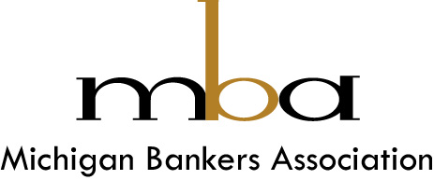

*Our Mission: Advocating for and supporting banking.*

*Our Purpose: Empowering the voice of banking through connections, growth, dreams and innovations for communities to thrive.*

507 S. Grand Ave.

Lansing, MI 48933

michigan.bank

517-485-3600

March 30, 2023

The Honorable Sandra Thompson

Director

Federal Housing Finance Agency

400 7th Street, SW

Washington, DC 20019

Dear Director Thompson,

The Michigan Bankers Association appreciates the opportunity to provide comments on the Federal Housing Finance Agency’s (FHFA) comprehensive review of the Federal Home Loan Banks (FHLBanks).

We are particularly grateful for the relationship we as an organization and that we an as industry in Michigan share with the Federal Home Loan Bank of Indianapolis (FHLBI). The partnership is for Michigan Banks to have access to liquidity, funding for housing and community and economic development as well as the ability to utilize grant programs to support and finance affordable housing, neighborhood improvements, first-time homebuyer down-payment assistance, aging-in-place accessibility modifications and supporting small businesses.

The importance of the FHLBs as a vital liquidity source for their member institutions has been ever more evident in recent weeks with the System raising historic levels of funds in the capital markets. This in response to heavy demand for liquidity from members in light of the developments surrounding Silicon Valley Bank and Signature bank, many of which just increased on-balance sheet liquidity to be prepared for the uncertainty created by these large bank failures.

We appreciate this opportunity to provide the FHFA with comments on the topics presented as well as on appropriate limits of that review. We look forward to further engagement with the comprehensive review and the follow on to promote a vibrant, responsive and resilient FHLBank System.

Sincerely,

T Rann Paynter

President and CEO