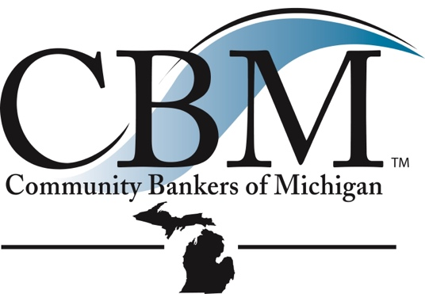
O n e M i s s i o n. C o m m u n i t y B a n k s.

March 17, 2023

Sandra Thompson
Director
Federal Housing Finance Agency
400 7th St SW
Washington, D.C.

RE: FHLBank System at 100: Focusing on the Future

Dear Director Thompson:

The Community Bankers of Michigan appreciates this opportunity to provide written comments on our position regarding the Federal Home Loan Bank (FHLB) system as part of the Federal Housing Finance Agency’s (FHFA) review of the Federal Home Loan Bank System. We represent Michigan banks with their headquarters in Michigan and nearly 100% are also members of the FHLBank Indianapolis.

Many of our members participate on the FHLB boards and on various committees covering all kinds of banking and community housing initiatives. Since its inception, the FHLBs have been a key part in helping community banks drive economic development and housing initiatives in the communities they serve. They are a critical piece of our nation’s financial infrastructure. The FHLBs help facilitate mortgage finance, help support low to moderate income housing initiatives in both rural and urban areas and are a vital source of liquidity for community banks, credit unions and insurance companies. All community banks in Michigan have come to depend on FHLBank Indianapolis as a reliable source of liquidity, using the advances to fund mortgages and manage interest rate risks. Without the use of FHLB advances and affordable housing products, the housing for low to moderate income households would suffer.

Community banks and the FHLBs have enjoyed a long and successful relationship over the past ninety years. Community banks provide local knowledge and have the necessary contact with builders, small businesses, economic developers, and community leaders. We know the housing developers and the community groups working on low to moderate income projects in our communities. The FHLBs partner with us and our communities to provide the necessary liquidity needed to complete many local projects that might not otherwise be achieved. Some have questioned if the system is sufficiently meeting the needs of today’s market. Unfortunately, those that do have that concern do not have the view that I have to see just how relevant the FHLBs are in supporting housing.

We fully support the review of the system – we always need to assess if the tools we have in place are meeting the current needs of all segments of our communities. There is always room for improvement and you should conduct periodic reviews to assure all stakeholders that the FHLBs are still meeting the housing finance needs in our markets.
830 W. Lake Lansing Road, Suite 250 • East Lansing, MI 48823 • P: 517.336.4430 • F: 517.336.7833 • e-mail: info@cbofm.org • www.cbofm.org

One of the main reasons the FHLB system has played such a pivotal role is that the FHLBs deal primarily with insured, prudentially regulated depositories – primarily banks and credit unions, along with certain CDFIs and insurance companies. These are the entities that have the financial stability and regulatory oversight to be solid partners with the FHLBs. We become very concerned when there is talk about having mortgage companies, crypto financial institutions, fintechs, industrial loan companies or other specialty finance companies becoming members of the system. Without the proper regulatory oversight this would be a slippery slope to navigate.

It is critical that community banks can access FHLB advances during times of economic stress or when there are opportunities to increase mortgage lending, participate in a local project, or help first time homebuyers. Keeping liquidity flowing so banks can lend even in difficult times is a big part of pulling out of a recession. If lending comes to a halt, there is no way to get the economy turned around. There is a delicate balance to be achieved – FHLBs need to continue to be a reliable source of liquidity that community banks depend on.

Consistent and reliable access to advances must be balanced alongside keeping the FHLB System safe and sound. Working with only prudentially regulated institutions and allowing only certain types of collateral goes a long way in keeping the system safe going forward. The introduction of non-regulated entities and esoteric and volatile forms of collateral will lead to increased risk within the system, a greater possibility of losses, and a potential failure of a FHLB, thereby increasing costs for all who rely on the system.

The CBM appreciates the opportunity to provide the concerns of our member banks for your consideration. We hope you will make needed modifications without weakening the critical role the FHLBs play in our nation’s financial system. Our banks and the CBM have an excellent relationship with the FHLBank Indianapolis and they have been a great partner in helping us serve all members of our community. Michigan is well served by the FHLBank Indianapolis.

Sincerely,

Michael Tierney
President and CEO

