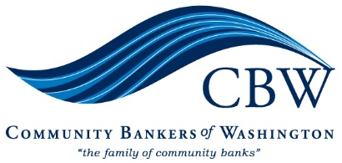

March 7, 2023

To: Federal Housing Finance Agency
RE: FHLBank System at 100

We appreciate the opportunity to highlight the importance of the Federal Home Loan Bank of Des Moines and its impact on Washington State’s economy and citizens. As you review the program, I encourage you to support and enhance FHLB programs so they may continue as a vital part of our housing economy.

New FHLB members must have prudent regulations and risk management similar to current member financial institutions. Allowing differently-regulated or less-regulated entities to join FHLB increases the risk for all parties, increases the costs of administering FHLBanks, and undermines the system for all. Recent news stories illustrate the need for improved regulation of non-traditional financial service providers. Until this is accomplished, protect the integrity and risk profile of the FHLB system by permitting only prudently regulated financial institutions to become members.

Washington State needs more affordable housing, with nearly one million Washington State households spending over 30% of their income on housing, forcing them into long commutes and financial struggles. FHLBanks have provided $1.28 million in affordable housing grants, $15.4 million in down payment grants, and $530.3 million in mortgage programs in Washington State. FHLBanks support housing as its mission through offering critical funding and liquidity to community banks that support their lending activities. Many community banks go well beyond what is required to support housing and economic development programs. The FHLB system is integral to our developing communities and will be an essential part of addressing Washington’s affordable housing crisis.

The FHL Bank system assists all sizes of banks in participating in the home loan and affordable housing market. Limiting participation by large financial institutions or imposing burdensome rules such as requiring an ongoing asset-based test or tracking the use of advances will negatively impact pricing stability, broad collateral availability, and material earnings for AHP disbursements. Any such rule would particularly hurt community banks and the communities they serve who significantly rely upon the FHLBank System’s low-cost and readily available liquidity. Participation by larger members stabilizes the systems and enables community banks to increase their support of housing programs, voluntary programs, and community investment.

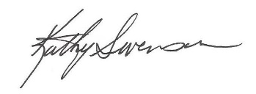
Best Regards,
Kathryn Swenson
President & CEO

