To: Federal Finance Housing Authority
IH Mississippi Valley Credit Union (IHMVCU) is an active member of the Federal Home Loan Bank of Chicago. The FHLB system has been working for 90 years with no credit losses, and from a Credit Union’s perspective the system should not be changed drastically at this time. In addition, the system’s current structure allows flexibility and responsiveness to meet our local member needs.

Our Credit Union uses multiple products through FHLB, and we rely on these products to better serve our members and community. Below is a detailed listing of the products that we use through FHLB and the impact these have on our members and communities.
- Advances: We actively use our FHLB line of credit to assist with managing our liquidity risk so we can fully serve our members. These advances provide us with a funding source for mortgage products throughout the year and in times where we would not be able to lend to our members. This impacts our members because without this product there would be instances where we would have to deny our members to receiving a mortgage loan.
- MPF: This product allows us to provide our members with another mortgage lending option that they can choose from to fit their personal and financial needs. With this loan product we sell the servicing to FHLB which in turn helps decrease our financial stress from a liquidity perspective. Lastly, FHLB has pricing that is competitive in the market which allows our members to be in a more affordable loan product. This impacts our members because without this product our members could be paying higher interest on other loan products.
- Down payment assistance program: We actively train and educate our members about this program, and so they can receive financial assistance if they are a first-time homebuyer. This is a program that most of our members are not aware of and something that we actively promote to our members and communities. This impacts our members because it allows them to be able to purchase homes that they may not be able to purchase because of lack of funds to cover the loan. This also impacts our communities because it can help boost and increase prosperity within our local communities.

We appreciate the opportunity to comment on the FHFA review of the system, and we strongly urge the FHFA to not make any changes to the current system because of this review. If you have any questions or concerns, please do not hesitate to contact me at sjorgensen@ihmvcu.org.

Thank you!
Sincerely,
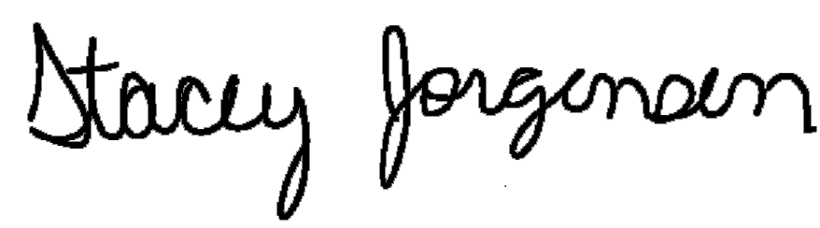
Stacey Jorgensen
ERM Manager

