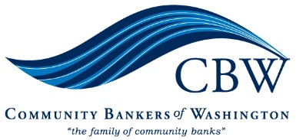
October 28, 2022

Director Thompson
Federal Housing Finance Agency
400th St SW
Washington D.C. 20224

Dear Director Thompson:

Thank you for the opportunity to provide written comment as part of FHFA’s Listening Tour for its review of the FHLB System.

The Federal Home Loan Bank (FHLB) of Des Moines is critically important for Washington State’s bankers and local communities. The FHLB of Des Moines serves 38 Washington banks and provides our state with over $7.3 billion in advances, $530 million in mortgage programs and $201 million in letters of credit. Additionally, the FHLB of Des Moines’ Affordable Housing Program has provided Washington communities with over $128 million in competitive grants assisting 16,563 homes and over $15 million in down payment programs assisting 2,918 homes.

The FHLBank System’s core mission of providing liquidity to its members is vital for our state’s banks. When our banks needed liquidity the most at the onset of the 2008 financial crisis and 2020 COVID crisis, the FHLB of Des Moines was reliably there to provide it. We urge FHFA to ensure that all of our banks continue to have full access to FHLB liquidity going forward, especially given today’s uncertain economic environment.

Washington’s banks are the lifeblood of our local communities. They provide the credit needs of our state’s families, farms and small businesses. Without access to credit, these communities would be greatly harmed and adversely impacted. Having full access to FHLB liquidity is critically important, not only to our banks, but also the communities they serve.

We urge FHFA to foster a strong and stable system by ensuring that all current members of the FHLBank System remain members and continue to have full access to FHLB services. It is essential that the FHLBanks continue to effectively serve their members through all economic cycles, and we are concerned that expansion to new non-traditional entities that lack robust oversight and are vulnerable to economic downswings may ultimately weaken the FHLB System and our members’ ability to serve our communities.

On behalf of our members and the communities they serve, we strongly urge FHFA to ensure that the FHLBanks remain a safe and stable source of liquidity and continue to reliably serve all of their members as they have for the past 90 years.

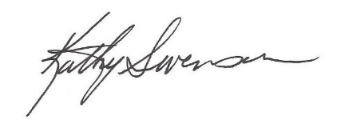
Sincerely,
Kathryn Swenson
President & Executive Director
Community Bankers of Washington

