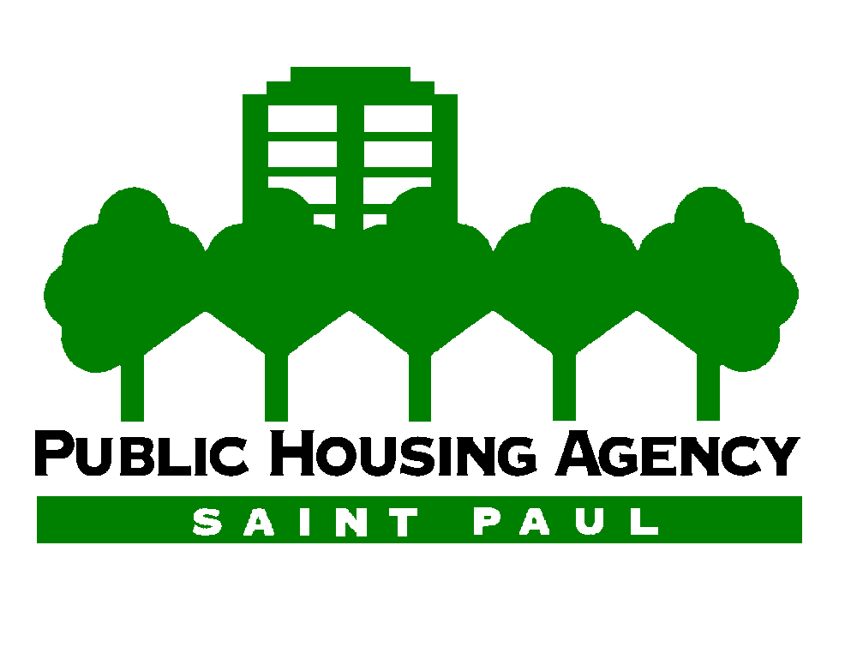
October 25, 2022

Director Thompson:
The Saint Paul Public Housing Agency (SPPHA) serves a portion of the nearly 3-million Minnesotans living in the Twin Cities metro area. Approximately three percent of the 318,000 residents of the City of St. Paul live in SPPHA-owned homes. The SPPHA owns sixteen Hi-Rise apartment buildings in St. Paul, all of which were built between 1959 and 1976. The SPPHA’s mission is to help families and individuals with low incomes achieve greater stability and self-reliance by providing safe, affordable, and quality housing and links to community services.
FHLB Des Moines is an invaluable partner to the SPPHA in achieving its mission. To continue to meet SPPHA’s standard of high quality now and in the future, our buildings require ongoing costly maintenance, including modernizing apartments, plumbing systems, and elevators. In particular, the Affordable Housing Program (AHP) grant funds from FHLB Des Moines enabled the SPPHA to complete the modernization of five elevators. Over 2,000 senior and disabled residents call our Hi-Rise buildings home. The modernized elevators provide these residents with the means to more easily and safely navigate the buildings, attend doctor appointments, socialize, and connect with community services.
AHP grants from FHLB Des Moines also provided the necessary funding needed by our team to replace building plumbing and completely modernize every apartment in three SPPHA-owned Hi-Rises in 2016, 2017, and 2019. Utilizing FHLB Des Moines funds, the SPPHA replaced all of the plumbing, upgraded kitchen cabinets, added new fixtures, updated the bathroom, repainted the unit, and replaced flooring. The AHP grant also enabled the SPPHA to minimize the inconvenience to residents by shortening the timeline to complete each unit to one or two months. Without assistance from FHLB Des Moines, the SPPHA likely would not have been able to complete this work in as many units for many years.
The SPPHA Board and staff are grateful for FHLB Des Moines’ timely support. The maintenance and updating it allows us to complete makes a big difference to the residents. Our staff and the contractors also take great satisfaction in the work and the outcomes. Seeing the joy on residents’ faces when their unit is completed and they are able to move back in makes it all worth it. After seeing their new apartment, some residents say that they cannot recall what their home looked like before. The AHP grant funds make an impact beyond just dollars and cents, they also demonstrate support and respect to the individuals that call our buildings home.
Sincerely,
Brent Feller
Construction Program Manager
The Public Housing Agency of the City of St. Paul

