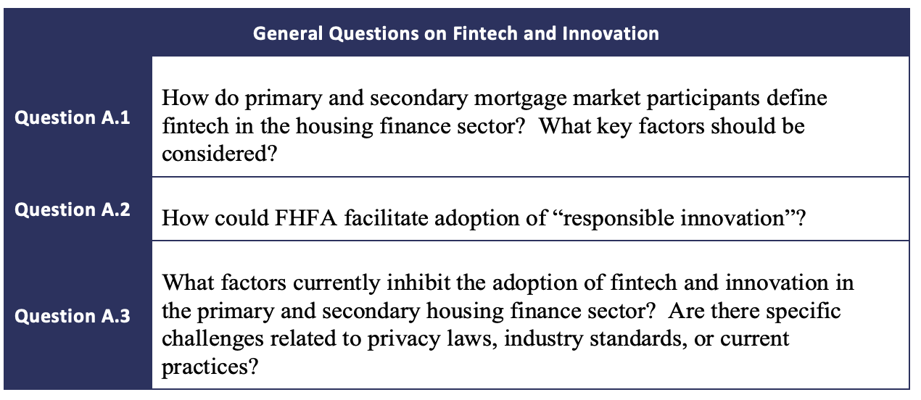

A.1

Fintech refers to technological innovations through software, software as a service, applications, artificial intelligence, machine learning, blockchain, cloud computing, cellular hardware, big data and the like which enhance or replace traditional financial process and delivery methods. Many FinTech providers have recently been focused on remote processing without in person interactions, mobile notary services, virtual home inspections, and asset and income verification in the mortgage industry.

Key factors to consider include the tools themselves, how they interact with existing infrastructure, the intended and unintended consequences of adoption, and the skills and leadership capabilities of the providers. A focus should also be on testing, implementation, and execution of stated objectives along with industry and consumer feedback. You cannot neglect to consider the speed, reliability, accuracy, impartiality and cost efficiency of the products.

Successfully combining the aforementioned factors takes knowledge and skill. As an example, Halcyon Still Water is focused on solving the complex issues that face many borrowers when applying for a mortgage loan. Determining the borrower’s ability to repay is crucial for lenders, but can be a source of frustration for many borrowers, particularly low income borrowers. According to the Poverty Fact Sheet published by the Institute for Research on Poverty and the Morgridge Center for Public Service at the University of Wisconsin-Madison, 42% of low-wage workers work irregular job schedules and 12% have seasonal employment. Inconsistent hours and secondary employment make the income verification process significantly more difficult and time-consuming, placing even greater barriers to homeownership ahead of low-income borrowers. Low-income borrowers are disproportionally Hispanic, Black, or other minority accounting for 30%, 22% and 6% of all low-income individuals according to the Urban Institute. Incorporating Halcyon’s income verification system into a lender’s process creates a faster, lower cost, more reliable and less frustrating customer experience that levels the playing field for underserved individuals.

A.2

While new technology is often touted to speed up the process, make it easier for consumers and lenders, not every solution is adopted. Despite 43% of lenders having some form of eClose capabilities, adoption was only around 16% in 2020. Stratmor provides the below chart showing the category of tech development, lender adoption, user adoption and net adoption. The chart clearly shows lack of adoption at both the lender and user levels.
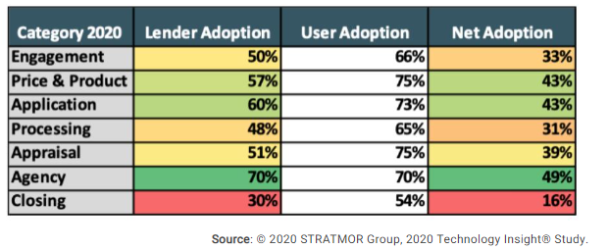
Barriers to adoption at the lender level include not knowing what is available, limited resources, regulatory risk, reputational risk, other priorities, and more.

FHFA can be a change agent to drive adoption of new technology, specifically where such technologies benefit goals of supporting traditionally underserved communities.

FHFA could drive change management in the industry and encourage adoption of new technology, specifically technologies designed to lower cost and increase home-ownership opportunities for low-to-moderate-income and minority individuals, by providing a certification of technology indicating the technology has been evaluated and meets a criterion set of standards(is not vaporware); integration into GSE or other approvals of the tech by the GSE’s; reps and warrants by GSE for outputs from the technology; and, Ensure that providers meet high data privacy standards.

A.3

Facilitating adoption will require addressing regulatory concerns, disparate impact and other unforeseen consequences, fungibility, cost, timeline to implement, and ROI. With historically low profits, lenders are focused on survival. Volumes and profits, as shown in the below chart, have continued to decline, Many companies are in their second, third, or fourth round of layoffs leaving IT departments stripped to the studs.

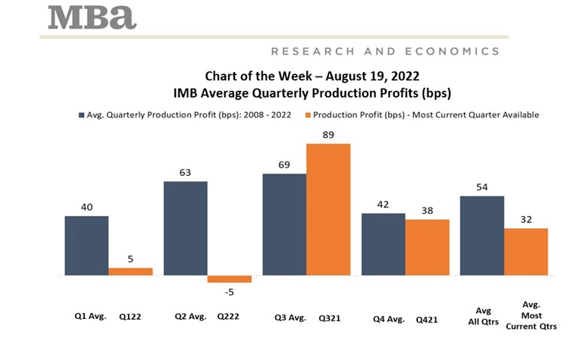
If lenders are to implement new technologies, they will need support. Support comes from vendor partners through providing strategic support and partnerships while aiding in reducing costs and providing additional revenue streams. Support must also come from sources like FHFA and the GSEs.

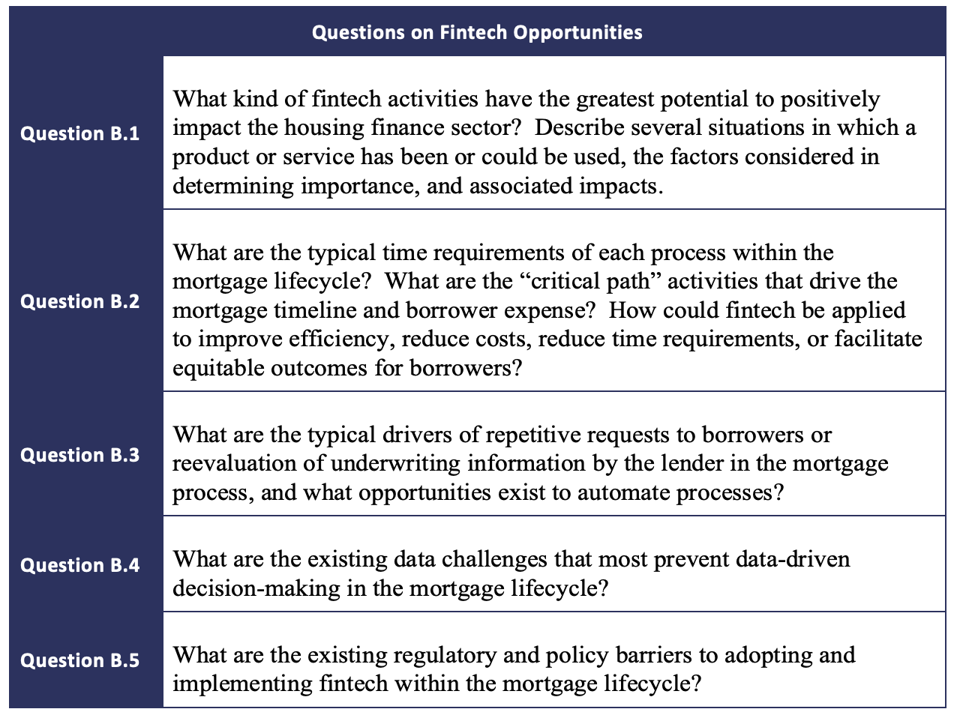

B.1
FinTech activities and products which increase efficacy, promote equality amongst borrowers, increase speed, reduce cost, and protect the personal information of individuals have the greatest ability to positively impact the financial housing sector.

The cutting edge of innovation lies in data. The acquisition of new data, replacing manual processes to collect data, analyzing the data, and placing the data into actionable insights which a lender, borrower, or both can quickly and easily act on are the cutting edge.
Halcyon's API integration with the IRS has the capacity to facilitate all of the above qualities and greatly influence positive change in the mortgage financial market. Quicker access to income and asset information allows for increased access to mortgages for all borrowers and shortens the life cycle of the mortgage lending process. The IVES service, which provides mortgage lending companies with IRS tax information on their prospective borrowers, currently takes several weeks delaying the loan process. Once integrated with Halcyon, they received their borrowers' tax transcripts within minutes to hours. In addition to increased time efficiency, Halcyon's solution reduced costs to both mortgage lenders and their borrowers. This cost reduction makes obtaining a loan more accessible to marginalized, financially disadvantaged individuals. With the recent increase in technological advancement, there is also increased risk associated with the transfer and accessibility of an individual's personal information. Halcyon's API integration is secure and meets all government regulations, ensuring that borrower's PII is protected.

B.2

According to data from Freddie Mac, the average time to close a loan hovers around 40 days, but varies based on market conditions and can vary significantly from lender to lender and borrower to borrower.

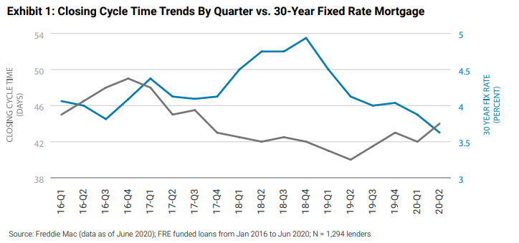

Critical path activities are income and asset verification, underwriting, collection of conditions, appraisal and inspections, title and insurance.

The adoption of digital technology is a key driver in reducing cycle times. Technology is able to automate processes and provide cleaner data allowing the dual benefits of cycle time and cost reductions along with increased accuracy and, in many cases, reduction in bias.

Current time requirements for each step within the mortgage lifecycle is a growing issue for mortgage lenders, their borrowers, and, in relation to tax data, the IRS. Due to the long timeframes, borrowers become disenchanted or disinterested in the loan process. Low-income borrowers often suffer a disproportional impact from the current time-consuming processes. Halcyon's solution facilitates equitable access to mortgage loans, regardless of socioeconomic status, ethnicity, race and gender. Furthermore, the IRS is inundated with form-based transcript requests (4506-C), which recently lead to inefficient allocation of government resources. Halcyon promotes borrower creation of IRS accounts, allowing for better communication between tax filers and the IRS. Having more borrowers creating IRS accounts increases efficiency in processing third-party authorization requests, as they can be completed electronically between Halcyon and borrowers. This method of approving tax information authorization requests significantly reduces the need for the current manual process.

B.3
Typical drivers of repeated requests for documents most frequently fall into the income and asset verification and updates to those documents.
We have been living in a seller’s market. Sellers have required pre-approvals from borrowers to have their offers considered. In an ever-competitive market, buyers compliantly responded and ponied up document after document to their lender to be pre-approved. Buyers often spent months searching for a home and making multiple offers before being able to complete a transaction. During that time, their income and asset documents would often expire requiring buyers to complete the documentation process again. Once the loan heads to underwriting, there are often questions from the UW requiring the borrower to gather additional documents. This causes an emotional strain more acutely felt by low-income borrowers who often have multiple jobs forcing time constraints and significant additional documentation requests to prove continuity of income.

Halcyon is helping to solve this problem. Halcyon is working to provide solutions that utilize tax data to drive a one-time request from the borrower which, similar to many asset providers, allows for updates to the lender without any additional burden on the borrower.

B.4
Issues occur in obtaining data, the ability to use data that is challenging because of antiquated systems, processes to make decisions without human intervention is limited, and trust in the data quality is poor. Using highly accurate data pulled directly from the source without human-intervention creates the ability to be highly efficient, less-biased, and automate systems.

Trusted vendor partners that help solve these solutions bring great value to the industry.

B.5

Existing barriers within the mortgage industry include requirements to implement and make regulatory required changes, non-approval of GSEs and other market participants of the output of those systems. Additional barriers are the long-life cycle to get changes made to existing P&P at agencies and the long vendor management and implementation cycles.

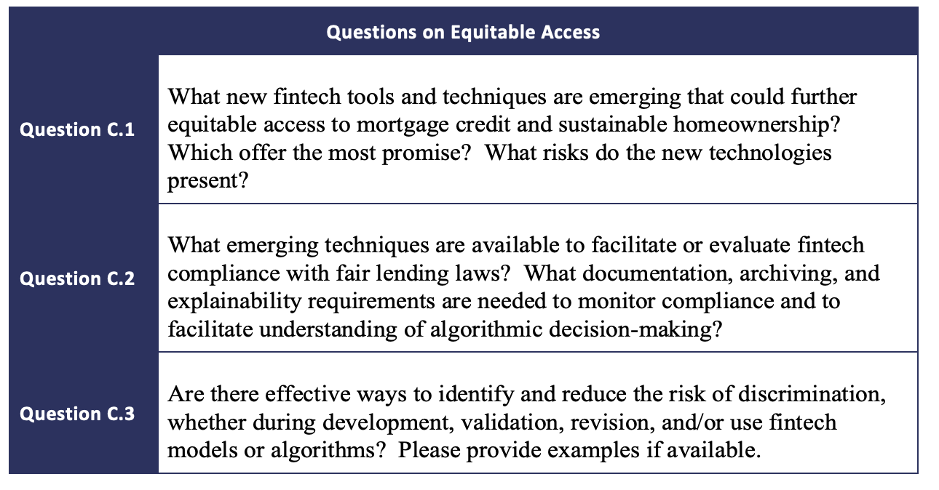
C.1
There are several fintech products that are faster, cheaper, and offer more secure access to borrower data, particularly wage and income data.

Shortening the time frame in which individuals can close their mortgage loans and reducing loan closing costs associated with the mortgage process levels the playing field for low-income individuals.

Department of Housing and Urban Development’s research shows “prospective homebuyers often do not know or understand their financing options….can encounter unexpected costs”. HUD’s research shows these same borrowers benefit when receiving homeownership education and counseling. Financial education is not just how to own a home, but how to manage taxes and invest for your future.

According to Jo Ann Barefoot in her report Digital Technology Risks for Finance, “use of new data types are showing great promise to make lending more inclusive, not less so. An example is the controversy cited earlier regarding use of alternative data in underwriting. Early research suggests that capture of alternative data, such as bank records showing the customer’s cash flow, can enable lending to many people who are currently screened out by traditional credit scoring, and that this can be done without loss of loan quality.Again, the regulatory standards for deciding what data can be used and how to demonstrate a business justification if disparate impact occurs are unclear.”

Research shows there is a need for adoption of technology to reduce bias, decrease costs for traditionally underserved communities, and improve the customer experience. Risks prevail in the marketplace including low rates of adoption, unknown bias in the AI/ML; inability to use outcomes in the PLS market; differentiation in lenders that offer or adopt different technologies and offer different services to their borrowers.

With Halcyon’s lower cost structure, speed, and ability to impact anyone filing tax documents with the IRS, there is the ability to have substantial impact. Having FHFA help address the risks to gain wider adoption will improve manufacturing quality and the consumer experience.

C.2
Participating fintechs in partnership with FHFA should provide a submission of relevant information to the GSEs or FHFA to obtain a certificate of compliance. The exact nature of what should be contained in the submission package, how it will be reviewed, how confidential data and vendor proprietary information will be secured needs to be considered in the final structuring of the program.

Framework exists today with each organizations Fair Lending Compliance Management Systems. While each CMS should be appropriate for the entities risk profile, a solid CMS includes:
- Policies and procedures
- Training materials and guidance
- Personanel and other resources devoted to the CMS
- Exception monitoring and oversight
- Fair lending self-assessments
- Provisions for taking appropriate and timely corrective action if an issue is discovered.

C.3

“Homeownership is a critical wealth-building tool, but not everyone has the same opportunities to become a homeowner. To create a more equitable and sustainable housing landscape, policymakers, thought leaders, and changemakers need to understand the trajectory of the homeownership rate – where it has been, where it is going, who it has benefitted, and who it has left behind….. Between 2020 and 2040, there will be 16.1 million net new households. Hispanic households will grow by 8.6 million, households of other races (mostly Asian households) will grow by 4.8 million, and Black households will grow by 3.4 million. White households will decline by 0.6 million….. People who were 25 to 44 years old in 2010 are the most affected age group, as the Great Financial Crisis hindered their ability to become or remain owners. The aging of the US population will cushion the drop in the overall homeownership rate because older households have higher homeownership rates. We project the overall homeownership rate will fall from 65 percent in 2020 to 62 percent by 2040….. If current policies stay the same, the Black homeownership rate will fall well below the rate of previous generations at the same age and result in an unprecedented number of Black renters over 65; we project elderly Black renters will more than double from 1.3 million in 2020 to 2.6 million in 2040.”

The above data from the Urban Institutes outlines the why behind the need for FHFA along with other leaders in the industry to focus on technology development. We cannot and should not leave minority homeowners behind. Our recommendation is for FHFA to run an accelerator or incubator and partner with fintechs in developing the technology along the way; offer resources for compliance review. Most people want to comply but don’t necessarily have the expertise. Provide this assistance at each stage of development and drive adoption within the industry through promotion of fintech partners.

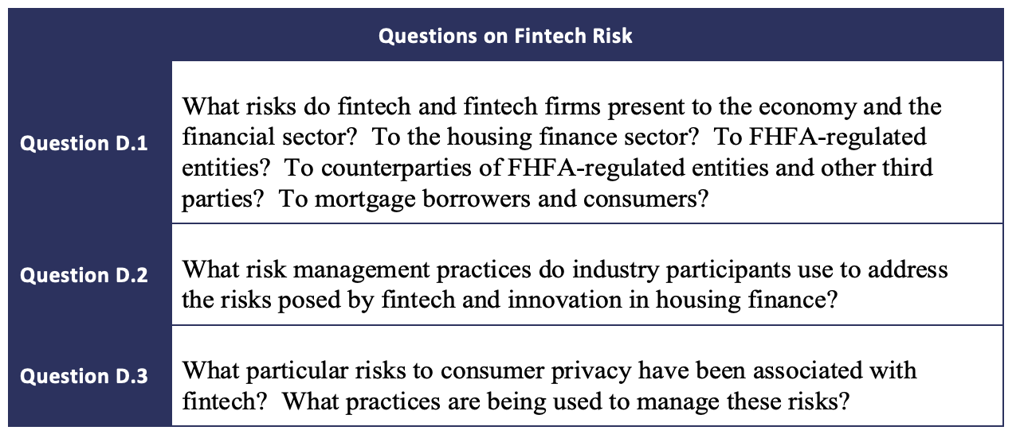

D.1

Reaching back to the Harvard published study by Jo Ann Barefoot, she eloquently states the risks. “One is the possibility that banks will fail to innovate sufficiently and will therefore lose market share. This does not appear to be happening yet, as reflected in the World Economic Forum study cited https://www.cato.org/blog/invalid-when-made-district-courts-madden-v-midland-decision https://www.nacha.org/news/federal-judge-dismisses-csbs-second-lawsuit-against-occs-fintech-charter earlier. It found that innovation is clearly altering financial products and practices but not, thus far, the industry’s structural makeup. Few fintech startups have reached sufficient scale to rival banks. The study does, however, point to the potential for Big Tech firms like Amazon, Apple, Facebook and Google to become major financial players if they so choose. Breaking Banks author Brett King makes a similar point, predicting that by 2025, the world’s largest bank will not be a bank, but rather a technology giant -- China’s Ant Financial. He notes that in 2016, Ant’s Alipay system processed $17 billion in mobile payments in a single day…..

Fairness and “computational ethics:” Another data-related risk for consumers centers on questions of fairness in how new types of data are used. As discussed in Paper 3, the availability of nontraditional data can bring tremendous benefits, enabling financial companies to authenticate identity and safely underwrite loans to people with complex credit profiles. However, concern is rising that these same processes could be misused or abused as financial companies leverage new data and AI in algorithmic analysis to guide business decisions like targeted marketing, pricing, and whether and how people qualify to open accounts or receive loans. Here again, those worries are exacerbated by the growth of IoT. Consumers’ activity can be tracked today to analyze online media activities, entertainment choices, shopping habits, and location.

Issues can be classified broadly around whether the data being used is accurate; whether the data set is sufficiently large to permit analysis for the purpose at hand; whether the model is using data elements that may act as proxies for prohibited factors such as race or gender; whether the model’s “training data” sets may be importing inappropriate biases due to “learning” from human decision-making that was already biased; how to evaluate whether the model is in fact highly predictive of risk (especially for use in long-term scenarios like mortgage lending, or any lending that has not been tested over a full credit cycle); and whether the model can be audited by regulators and other risk reviewers to determine, among other things, whether it is both predictive and fair under the law.

Proliferation of providers: Policymakers will also have to fashion ways to regulate very small innovators, which will be able to reach consumers on a scale never before imagined. Small startups are likely to be disproportionate sources of both beneficial new ideas and rising harm such as incompetent advice and operations, fraud, and high rates of business failure that can leave customers stranded.

An overarching problem is the pace of change itself, which will outstrip both consumer understanding and industry and regulatory readiness.”

D.2
It has long been a regulatory concern to manager counter party risk. Firms throughout the mortgage ecosystem have compiled significant vendor management systems. A typical vendor management process will include a review of a vendor’s ability to meet or exceed current regulatory requirements in relation to fair lending and other, related, regulations. In addition, there is a review of their data privacy and protection measures.
D.3
Jo Ann Barefoot notes “Concerns about data security are well-grounded. The 2015 data breach at the federal Office of Personnel Management compromised personally identifiable information like social security numbers on more than twenty million people. The 2017 breach at Equifax exposed an estimated 143 million consumers to identity theft and fraud. As discussed previously, banks are already at risk for data breaches due to aging and siloed IT systems in both industry and government. Identity theft is commonplace. The Insurance Information Institute reports that $16 billion was stolen from 15.4 million consumers through identity theft in 2016, and the trend is rising. The dark web runs thriving markets in stolen data which, depending on type and how long ago the breach occurred, can range from a social security number selling for a dollar and something like a PayPal account going for $80. Cyber-insecurity is especially high in the developing world.”

If there are not adequate controls implemented by the providers or a provider must be shut down for non-compliance, either by a regulator of the firm using the technology, consumer harm can occur.

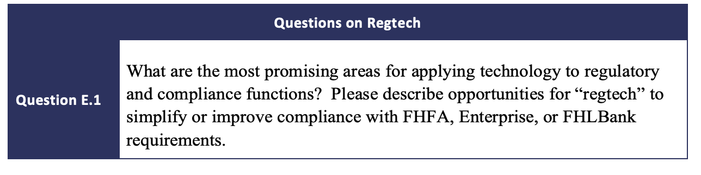
E.1
Regtech has the potential to solve the some of the regulatory problems of smaller institutions, community banks, small and mid-sized IMB’s (independent mortgage banks), and other smaller players who often have disproportionally high compliance costs. Providing standard solutions that can be implemented with fewer challenges poses the opportunity to simplify compliance and reduce the cost burden to smaller players driving

Additionally, some of the savings in using other tech could be applied to funding greater CMS internally at institutions.

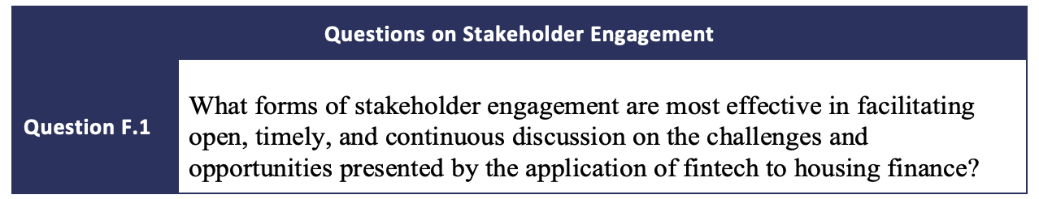

F.1
People buy painkillers not vitamins. We encourage the FHFA to focus on relieving pain points. Meeting with industry participants from a variety of stakeholders, including lenders and fintech providers like Halcyon who are actively working on solutions, to identify and prioritize the pain points to address.

The FHFHA should have effective and impactful stakeholder communication. Noting that listening includes observing the actual behavior of lenders and borrowers.

All stakeholders should approach the work with an open mind – a blank slate – open to all ideas. FHFA will need to set the stage for this to take place. In addition, FHFA must be sure to include the right stakeholders – and get them all to the table early. This includes lenders of multiple sizes operating different models, including people from different parts of the organizations, and including a variety of fintech partners.
Finally, the FHFA must be transparent and provide feedback on the learnings and what will be done with the information obtained,
F.2
It is our opinion the industry and consumers would benefit from a tech-sprint focused on wealth creation for disadvantaged borrowers. Areas of focus could be on education and increasing efficiency in the process to lower costs that could be passed onto consumers. Winners of the tech-sprint should receive funding from the GSE’s for further development of their winning idea and a GSE pilot of their idea to field test and bring the idea to the market.

