Thank you for giving us the opportunity to submit comments on ways the FHLB AHP Grant could be more effective, and efficient. We are most familiar with the Federal Home Loan Bank of Indianapolis and have been successful in receiving AHP awards in the past. We internally polled people on their experience with applying for AHP funds and have compiled their comments below. The first group of comments relate to question #1 and are more about how the application is inputted into the application system (.GIVES).

.GIVES
- It would be helpful to allow more people to access an application instead of the person that starts it is the only person that can edit it. We frequently work in teams and have several people working on different sections. Having more people able to edit the application will make it a bit faster to input.
- A challenge we had was the size limitation and amount of documents we were able to upload. We had to break down environmental reports into several documents to stay below the size requirement, then had too many documents to upload. Environmental reports can be quite lengthy, especially if a project is far along in the process and has several environmental reports and studies.
- Another challenge we encountered was the member bank found an error on a document that was uploaded, but since the application had been sent to the member bank, even after it was sent back to the sponsor, it wasn’t able to be edited or deleted.
- When uploading documents, the order in which documents were to be uploaded seemed out of sync with the section of the application they were inputting.
- The profroma section doesn’t have enough sections to properly input a proforma to match up with other funding sources. For example, there is a place to input a future inflator for expenses, however, there isn’t a place to add a second inflator at some point in the future. A suggestion would be to have a global proforma in excel for sponsors to input their information and then upload onto the website. This will also help with allowing the sponsor to flip back and forth between tabs to ensure the data entered is correct.
- While we are grateful for the step by step guide to input the data, it would be helpful to have a complete list of application questions and input fields outside of the .GIVES system to allow the team to prepare answers ahead of entering the application as some screens will not let you advance without answering all questions.
- Another suggestion is to make .GIVES full screen. There are some pages where it looks like you can see everything but you actually need to scroll down and there is more to see (picture below for context – it looks like 1 Exhibit 1 Check….pdf is the last document because the box has a bunch of white space below it, however there are more below that).
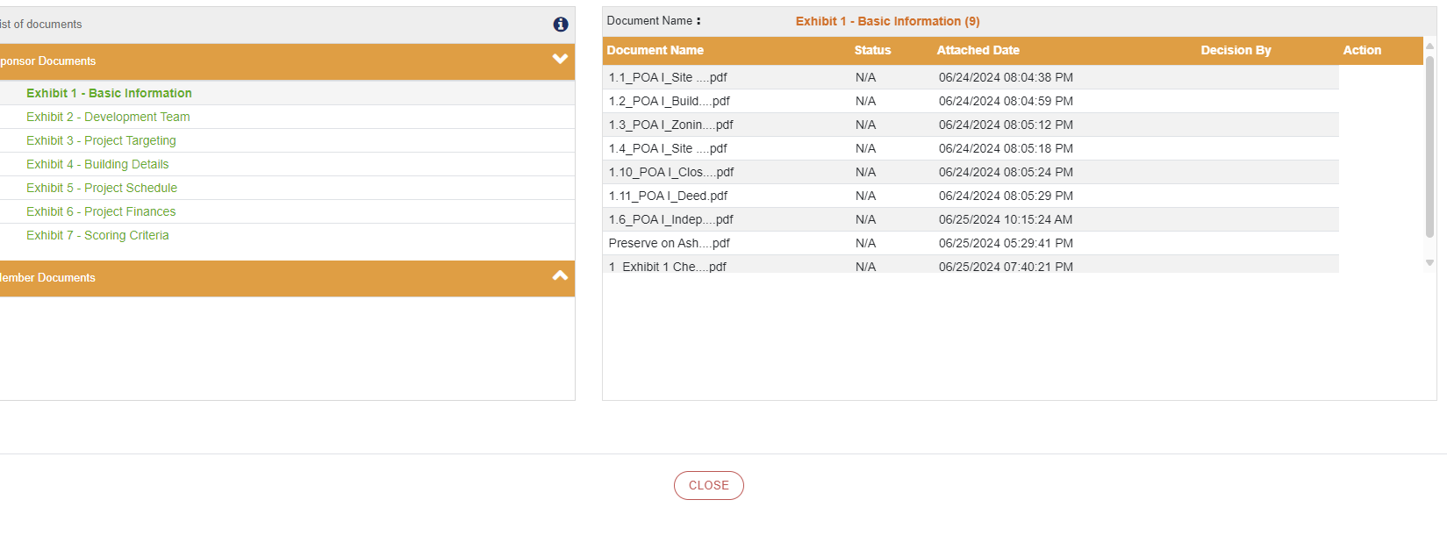
Question 2, the AHP process is cumbersome and requires a lot of documentation. Projects submitting for funding could be a project in concept only to a project currently under construction and the documentation available for one may not be the same as another. A suggestion would be to break the checklist down into separate checklists to show what is needed for a project pre-closing, post-closing, and post-AHP award. Some of the documents requested are not available at the time of application and it gets confusing as to what to provide. Requesting all of the documents on the checklist is more that is required for the major funding sources at the time of application.

Question 3, The AHP application process does duplicate other funding sources quite a bit. A lot of the same documents are asked for and need to be submitted. Timelines for things can get a bit tricky. Depending on where the project is in the closing/construction process, some reports may be older than FHLBI requires and must be re-done. For example, a market study may be older than 6 months if a project is already under construction. If the project is under construction then several other lenders have most likely already review the market study and found it to be acceptable. The amount of time projects are taking to close has been extended over the past several years, especially with new/updated environmental requirements.
The readiness points also contradict some of the required documents and the timeframe they are expected to be in. For example, a market study and appraisal are typically completed at the front of a project process, but to receive points as ready to move forward (or already closed) those documents are most likely stale based on the FHLB I-Plan timelines.

Question 4, We support FHLB’s differentiating their requirements for small projects, specifically LIHTC projects versus non LIHTC projects. The documents submitted can vary depending on the project type as well as the scoring. It is not uncommon for funding sources to have separate pots of funds and separate scoring criteria for the different project types. This could help make the application process more straightforward for the project types and compete more fairly. It would also allow FHLB to adapt their scoring more towards the state QAPs for LIHTC projects. Better mirroring of the QAP would also help make the submissions easier and more efficient.

Question 5, We do not use consultant for AHP applications and we cannot answer this question.

Question 6, Better alignment with the QAPs could help align projects across funding sources. Not only with scoring items, but with income targeting. The LIHTC program allows projects to select income averaging as long as the average income across all units doesn’t exceed 60% AMI, projects can go up to 80% AMI. This is a great way to help integrate income levels across communities.

Question 7, The biggest challenge we have that if improved could make a big difference in the application process is the .GIVES site. We find it clunky, not easy to navigate, it is not very intuitive. We appreciate the step by step instructions, but only using the website a few times a year, we have to reference those instruction sheets each time.

Question 8, Better alignment with other funding sources and requirements would help simplify the process. AHP is a smaller gap filler source in many cases and having conflicting requirements and scoring makes a deal more expensive as sponsors must fit in as many scoring requirements as possible. Also considering AHP is typically a smaller part of the capital stack, possibly removing some of the readiness to proceed points would be helpful. All funding sources want to be the last source into the project with every other source committed, however, not having a solid capital stack in place delays the closing of projects due to the uncertainty.

A few other suggestions we came up with while contemplating your questions are below.
- Consider a running review of total per unit development costs each funding round to use as the maximum in future I-Plans. The 2024 I-Plan only allowed $299,999 without further justification. In our experience, this number is low and unrealistic for new construction. Also, scoring requirements can get costly to implement as well.
- Different states call similar documents different titles. We request an explanation in the exhibit checklist of what the FHLB is asking for, such as, Certificate of Existence. That is called a Good Standing Certificate in Michigan. A Co-Sponsor Agreement could also be called a Development Agreement, so having a description of what that is will help the sponsor provide the correct documentation.

Thank you again for allowing us to suggest improvements and efficiencies to this very helpful program.

