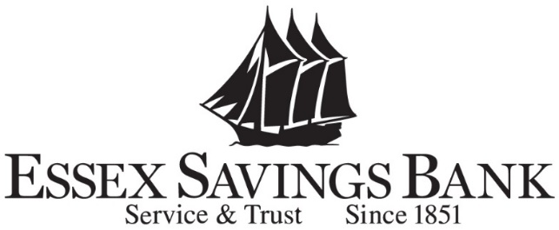

Corporate Office

35 Plains Road, P.O. Box 950

Essex, Connecticut 06426-0950

Telephone: (860) 767-4414

July 12, 2024

Essex Savings Bank has been a member of the FHLB Boston since 1995. As a small mutual savings bank, we have appreciated the value of our membership. We have taken advances over the years for liquidity needs as well as to mitigate interest rate risk. Especially in times of uncertainty, such as the current market environment, it is reassuring to know we have access to liquidity should the need arise. It is also beneficial during periods of rapid loan growth. Essex Savings Bank considers the FHLBB as our primary outside source of liquidity funding.

Essex Savings Bank has also utilized the AHP programs to assist with the development of three affordable housing projects in our market area. Two of these were for elderly housing – which included Essex Place, Essex, CT and 57 Sheffield St, Old Saybrook, CT. These two projects created a total of 37 units of much needed affordable housing for seniors in our local market area. We also utilized the AHP Program for the Spencer’s Corner project which created 17 units of affordable housing in Centerbrook, CT. Without the AHP funding, none of these essential projects would have been possible. We continue to seek local opportunities to utilize AHP funding and provide much needed affordable housing in our communities.

During the pandemic, Essex Savings Bank was the recipient of two grants available through the Jobs for New England program. These grants allowed us to assist many local businesses and non-profits who were the most severely impacted by the pandemic restrictions. The recipients utilized these funds to cover overhead and in some cases make renovations to accommodate changes necessitated by the pandemic. This funding provided a necessary lifeline to businesses in their time of need.

The Federal Home Loan Bank of Boston also made a cash award of $2,500.00 through its Grants for New England Partnerships (GNP) program to Literacy Volunteers Valley Shore on behalf of Essex Savings Bank.     
  
Essex Savings Bank has also granted a $400,000 term loan to a commercial borrower for business expansion which had an interest rate subsidy through the Jobs for New England Program. This loan enabled the borrower to hire three additional employees who were all LMI individuals.

The Bank employees have also taken advantage of some of the training opportunities provided by the FHLBB. We are grateful for the partnership we have enjoyed for the past 29 years and look forward to continuing our relationship for many years to come.

Sincerely,

Diane H. Arnold

President & CEO