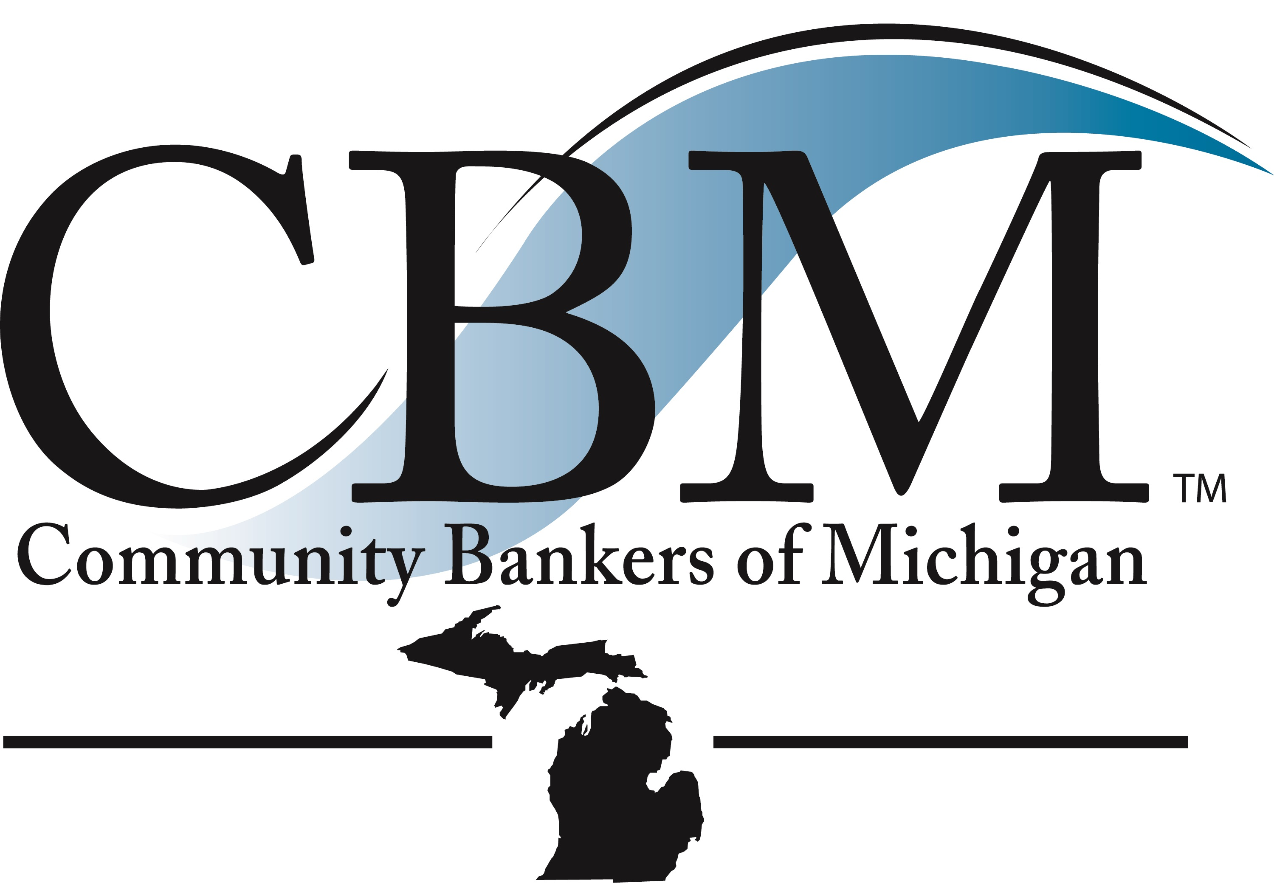
O n e M i s s i o n. C o m m u n i t y B a n k s.

July 13, 2024

Federal Housing Finance Agency
The Honorable Sandra Thompson
Division of Bank Regulation
400 7th Street, S.W.
Washington, DC 20219

Dear Chairperson:

The Community Bankers of Michigan (CBM) is responding to the request for information by FHFA on the Federal Home Loan Bank (FHLB) system on behalf of the banks and associate members in Michigan. We applaud the FHFA for conducting the yearlong review of the FHLBsystem that culminated in the release of the FHLBank System at 100 Report – Focusing on the Future. It is a sound operating practice to take stock of where things are with regard to the evolving needs of the country and the current status of the system. We do, however, have concerns about a number of concepts brought up in the report and via comments by executives at FHFA and we would like to address those concerns in this letter.

The Federal Home Loan Bank System was created by Congress in 1932 to help get the country out of the ravages of the Great Depression. The FHLB System has proved its worth in every major downturn for the US– and we all remember what a vital role the FHLB’s played in providing liquidity to the nation’s financial institutions during the Great Recession in 2008-2010. The FHLB System is a cornerstone of a strong and resilient US financial system, and it is also a major source of financial resources and expertise to support low to moderate income housing initiatives across the nation. FHLB’s are the largest source of private grant funding for affordable housing in the USA. Since 1990, the FHLBanks have collectively made available $8 billion in affordable housing subsidies assisting more than 1 million US households in conjunction with the financial institutions they serve.

On behalf of our member community banks across the state of Michigan, the CBM strongly urges the Federal Housing Finance Agency to avoid making any significant changes to the critical role of the FHLB’s especially at this uncertain time for the US economy. The sustained high level of interest rates in the US has put a significant strain on bank and credit union interest margins and liquidity, and in addition has caused credit concerns for certain business segments. The US Government is running record annual budget deficits – currently on pace to equal nearly $2 trillion per year – and financing the record national debt at $34 trillion is one of the major contributors sucking the liquidity out of the financial system in the US. Banks and CU’s have seen deposit runoff for the last several quarters and with it US lending has been curtailed - all of which adds to an uncertain economic outlook for our nation. Any proposed changes that would impact the vital mission of the FHLB’s in providing liquidity to the nation’s financial institutions would be a potential trigger to ignite a recession and the possible return of the pain and suffering US consumers and businesses endured in the 2008-2010 Great Recession.

Community banks rely on the FHLB’s to help fund their balance sheet especially in times of economic distress which in turn provides them with badly needed liquidity so they can continue to provide loans and banking services to their communities. Without the liquidity of the FHLB’s economic recessions would be much more severe for communities across the country as a key source of liquidity to small businesses, consumers and family farms would have been lost. In the difficult economic periods where financial institutions need the most liquidity, they rely much more heavily on advances from the FHLB system as a vital part of meeting a portion of their liquidity needs. Advances at FHLBanks increase when the economy dips and part of the magic of the incredible design of the FHLB’s as part of the nation’s financial system is the increased demand for advances in a tough economic time triggers higher profits at the FHLB banks and in turn generates significantly more funds for low to moderate income housing projects when they are needed the most. This is exactly the way our nation’s leaders designed the system to work and it functions amazingly well for all parties.

There has been occasional criticism regarding the so-called excessive use of advances by a handful of large poorly managed banks that failed in 2023. There is some validity to this observation – but in the end the system functioned exactly the way it should have. Liquidity was provided for an orderly transition of the failed institutions to new ownership, all FHLB advances were repaid, and the losses to the FDIC deposit fund have been repaid by the nation’s banks. The FHLB System is excellent at securing any advance made and losses on advances are non-existent as they are all collateralized by assets held by the banks, credit unions, and insurance companies receiving the advances. The FHLB credit structure has been tested in many downturns and losses on advances have never been an issue of concern. The FHFA should work with financial institution trade groups to gain consensus on any potential changes to how advances are handled. The ICBA and the ABA are fully capable of working with the FHFA to work through all potential considerations with regard to any proposed changes to advance policies and no changes should be proposed without their sign off and support. We have significant mortgage business expertise at the CBM, and we would also be willing to participate in the process to review the advance program if a review was necessary – which we do not believe is warranted. There are issues with every government program – SBA loans – particularly those done directly by the SBA have significant losses but at least the bank generated SBA loans are essential to the healthy functioning of our economy and the vibrancy of small businesses, the PPP Program had significant fraud, yet it saved the jobs of 75% of Americans and kept us the #1 economy in the world. We can find issues with every single government program out there – student loans, unemployment benefits, Medicare and Medicaid fraud, Social Security fraud and abuse – it is all true but the overall positive impacts of every one of those programs far outweighs the negative consequences that are part of every major government program. The vital importance of FHLB advances to the financial system especially in critical times cannot be overstated and the concerns about a handful of organizations does not amount to a proverbial “Hill of Beans” and should not create any kind of overreaction to a very minor issue on the part of FHFA.

The Federal Home Loan Bank System is a critical part of the nation’s mortgage finance system. Through their purchases of mortgages, the advances they provide to financial institutions, and their outsized impact on low to moderate income housing and financing initiatives. Their role is to be there to help lead and support a functioning housing market for all consumer segments of the US with a special focus on low to moderate income housing. FHFA has proposed some potential regulatory hurdles and reviews as part of FHLB’s working with financial institutions. This is not part of the Congressional authority granted to the FHFA. Banks, credit unions and insurance companies are already in the most highly regulated industries in the nation, and each has its own prudential regulators. It is well beyond the scope or authority Congress intended for the FHFA to get involved in any type of regulatory review of financial institutions as part of determining eligibility for advances. Opening this door could lead to potential abuses like we saw with Operation Choke Point where the federal government and its agencies unlawfully tried to impose political priorities on which businesses could be financed. These attempts to impose political priorities on private enterprises is abhorrent to the American free enterprise system and will not be tolerated by financial institutions or our trade groups. The recent decision by the US Supreme Court rolling back the Chevron doctrine reaffirms that agencies cannot rule with executive fiat and must work under current specific laws, and guidelines. Any changes to existing standards should be developed in concert with industry groups so they have the buy-in of all concerned parties. Banks must comply with CRA regulations and every bank in the US has a publicly available CRA rating. Banks that have a satisfactory or better CRA rating should face no additional scrutiny by any other federal agency on housing matters outside of the current CRA standards. The FHFA cannot and should not give any consideration to stepping into the territory of prudential bank regulators and does not have any Congressional Authority to try to impose regulatory lending requirements as part of the advance process. The CBM and other trade associations would prefer to work in concert with you through working groups on any proposed changes so we can jointly develop acceptable changes for all parties. The last thing we would want to do is to have to resort to legal action to block any unsanctioned and unacceptable changes to advance criteria, but if necessary, especially since the Chevron ruling, we would not hesitate to take legal action in concert with other industry groups to protect the rights of our member banks. We would much prefer to see a collaborative effort on the part of FHFA and the financial institution trade groups to develop any changes we can all agree to that would also stand through the changing political waves in our country. When we work together, and all agree to changes and updates, then we move permanently forward and don’t see it all washed away with the inevitable changing of political administrations. There is no doubt on anyone part that we have a major problem with housing affordability and the availability of low to moderate income housing in America. We at the CBM have identified this as a major challenge in Michigan just like it is across the country. Our team and the banks in Michigan stand ready willing and able to work with community groups, state and federal government entities including FHFA and the FHLB’s, housing industry leaders and any other organizations to address this problem and to develop effective solutions for all consumers.

The last matter we want to comment on is the structure of the FHLB System. The current structure functions very effectively. There are differences in the size and scope of each FHLB, but each serves its communities well. The Federal Home Loan Bank of Indianapolis serves our member banks in Michigan and has a vibrant hub operating in Detroit in addition to their main office in Indiana to ensure both Indiana and Michigan are supported. The management team at the FHLBI is exceptional and their outreach efforts in Michigan and Indiana are incredible. They touch critical communities in Michigan like Detroit, Lansing, Flint, Saginaw, Benton Harbor and also serve our rural communities. I was a speaker at the Michigan Civil Rights Summit in Detroit in June and the affordable housing programs of FHLBI and the Michigan Housing Development Authority are the center points of the affordable housing efforts here in our state. We covered these programs in detail for the attendees of the Summit. The FHLBI works with the CBM and our member banks and community organizations to get badly need housing finance support to all communities in Michigan but especially to low to moderate income communities in both urban and rural areas. We do not support any contemplated consolidation of FHLB’s. You never get the same attention paid to local communities when you make something bigger, and you consolidate it even further away from local markets. We see it in bank and credit union mergers all the time. When organizations get consolidated local decision making goes away and with it connection to the local communities often withers and dies. The exact same thing will happen if FHLB’s are consolidated. There will not be significant savings or efficiencies in any consolidations but there would be a loss of connection and responsiveness to local communities, so we strongly suggest the system be left intact. The FHLB’s collectively generated over $1 billion in profits so there is no financial reason to tinker with the structure of the system and we encourage the FHFA to maintain the current structure. We would be supportive of back-office efficiency enhancements that might improve effectiveness but the customer facing parts of the organization should not be restructured.

We are huge supporters of the Federal Home Loan Bank System and all they do for the nation’s financial institutions and for their critical role in the nations housing market. Our member banks and our communities across the great state of Michigan have benefitted from the major impact the Federal Home Loan Bank of Indianapolis has had on a properly functioning banking system and from their outsized role in affordable housing. We are helping the FHLBI roll out the Affordable Housing Program with $28 million in funding for housing grants and the Down Payment Assistance and Home Repair Program with $15 million in funding across Michigan to our banks and community groups. These are significant programs that have a major positive impact on housing for low to moderate income families across our state. We are proud to play a role in helping every Michigan family achieve their dream of homeownership and we are very thankful for the outstanding support we receive from the exceptional team at the FHLBI.

Thank you for the opportunity to comment on the FHLB System and we hope you will work with industry groups to make measured and mutually satisfactory adjustments to a system that is vital to our country’s economic stability and prosperity.

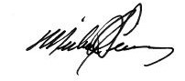
Sincerely,

Michael J. Tierney
President and CEO

CC: Martin Gruenberg, Chairman, FDIC
Michael J. Hsu, Acting Comptroller of the Currency and Director, FDIC
Rohit Chopra, Director of the Consumer Financial Protection Bureau and Director, FDIC

